Willow Class
Year 1 Home Learning Pack
Spring 2021 Week 2 – week commencing Monday 11th January 2021
Change Makers/Enchanted Woodland
Dear Parents and carers,
Welcome to week 2 of lockdown learning. Please find below some ideas of activities you can try and these can be completed at home or at school. I hope these are useful.
I am aware that we all have different circumstances; not everyone has access to a printer or device for running apps. You don’t want your child looking at a screen all day. Please let me know what works and what you need as well as anything that’s proving difficult and I will try to adapt.
- Keep reading! That means read to and with your child, not necessarily school books – just keep reading, more than anything else!
- Practice reading and writing keywords (see the list below).
- Do practical stuff; cook and bake together. Get outside and take exercise! Most importantly try to stay safe and well and just have a go. You know your child better than anyone!
I am posting this new homework with videos on Teams and on the class pages. Please let me have a piece of English, Maths and Topic work by Monday each week, as photos of their work posted through Teams. Please email if you have any queries: scheney@bolneyprimary.school
Let me know if there is anything I can help with.
Take care and stay safe, lots of love, Mrs Cheney
Reading
Send me a photo of the books you’ve read this week.
Which was your favourite?
English – Writing
Woodland Animals
How many Woodland Animals native to
the UK can you name? I named 11 working with friends in school – can you beat that? You will need this list next week when we move on to fact writing.

Please share this with me on Teams.
English – Phonics
I am producing and uploading phonics videos for phonics phases 2, 3, 4 and 5. Most children should start with phase 3. Children will need paper to write on during the video clips. They take a while to produce
Phase 3 sounds oa ar oo/oo or igh
Phase 4 – longer words sounds
Phase 5 – alternative ways of longer words sounds

Please share this with me on Teams.
Science
Winter Weather Diary
Keep a Winter Weather Diary.
Watch the Shirley Hughes Video clip, Cold. Practice writing the days of the week.
Write down what the weather is like each day.

Senses Walk
Go for a walk in the woods. Use your senses and draw and write what you can:
- See - Hear
- Touch - Smell
Stay safe and make sure you don’t eat things you find. Make sure you wash your hands after your walk.

Please share these with me on Teams.
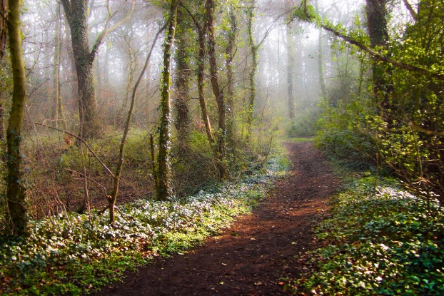
English Challenge –
A Walk in the Woods

Can you write your own story about this path into the woods? Who will you meet? What will happen?

Maths -- 3d shapes
We have already looked at 3d shapes. This week we are learning to:
- name 3d shapes
- describe the features of 3d shapes
- sort 3d shapes.
See shape activities below. These are duplicated in my video so you do not need to print these.

Please share this with me on Teams.
Maths Online
Shifting Shapes – a great 3d shape game
www.ictgames.com

Maths Shape Song
https://www.youtube.com/watch?v=ZnZYK83utu0
Phonics Resources
www.phonicsplay.co.uk/resources/phase/3
The Phonics Play website has brilliant resources for all phases and some of the activities are free.

www.bbc.co.uk/iplayer/episodes/b01cz0p1/alphablocks
I love Alphablocks!
TV Resources
CBBC TV
www.bbc.co.uk/schedules/p00fzl9r/2021/01/11
From Monday 11th January CBBC is programming sessions to support primary education
on CBBC, starting at 9am Monday to Friday.
My favourites are Deadly 60, Operation Ouch and Celebrity Teacher!

Joe Wickes YouTube Kids Workout
https://www.youtube.com/watch?v=6oIorMNtw5g
Joe Wickes is doing his daily workout for kids again, starting from Monday 11th January at
9am on his YouTube channel.
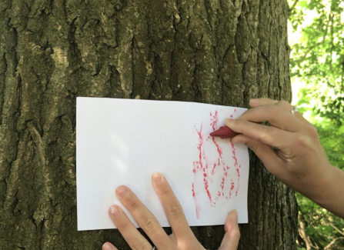
Science - Tree Barks
Hold a piece of paper over the bark of a tree and rub a
crayon or pencil gently rub the bark.
Try doing this to 3 different trees.
Can you find out what type of trees they are?
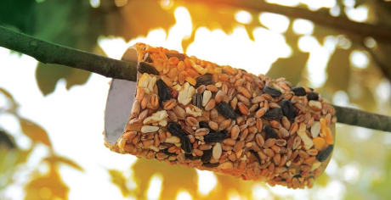
Science - A loo roll bird feeder
Messy but fun!
In 2 weeks time we can take part in the RSPB Great British BirdWatch. You might like to start feeding the birds to encourage them and it will help you learn about the birds where you live. You can make this simple bird feeder:
1. Cover a cardboard tube in peanut butter (no added salt and sugar versions are best for birds).
2. Roll it in bird seed and thread some string through the hole.
3. Tie it up in your garden where birds will feel safe eating.

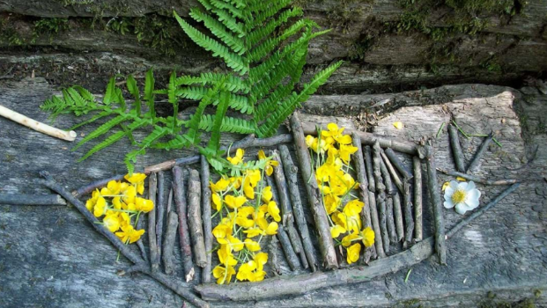
Creative - Make nature art
Use natural materials like leaves, petals and sticks and use them to make a picture or sculpture. Please make sure you don't pick wildflowers, however, as they are important for wildlife and some are protected by law.
Wellbeing Tips from Mrs Harvey
Activity
Learning when to take time to breathe can you feel happier and more comfortable.
Practice this easy technique a few times until you feel relaxed.
1. Think about a colour that makes you feel happy – this is the colour of good feelings.
2. Think about a colour that doesn’t make you happy – this is the colour of your not so good feelings.
3. Now close your eyes and take a deep breath in, imagine the breath is the good colour.
4. Now breathe out and imagine it is the not so good colour and blow it away, out of your body.
KS1 Story – Under the Same Sky
https://www.bbc.co.uk/iplayer/episode/m000hsff/cbeebies-bedtime-stories-750-tom-hardy-under-the-same-sky

Well-being tip:
Be sure to get enough sleep! How many hours do you think you need?
https://www.nhs.uk/live-well/sleep-and-tiredness/how-much-sleep-do-kids-need/

1. Name 3d shapes
Answers
2. Describe the 3d shape using 2d names. What can you see?
cube | cylinder
cuboid | pyramid
cone | sphere
Can you find an everyday object or shape at home to match each type?

3. Which is the off one out? Why?
1.
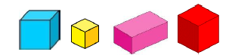
2.
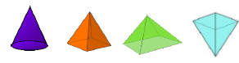
3.

