Holly – Friday 18th October 2019
Spelling:
This week we have revisited the ‘double the consonant to keep the vowel short’ rule.
e.g. dreaming has a long ee sound so the consonant is not double to make dreaming.
Pop is a short o sound so the consonant needs doubling before and a suffix -> popped.
Task: We have played this game in class this week – roll a dice twice to get your grid reference – find the root word in the box and apply the double consonant rule.
You can play against someone to see who is the first to get 3 in a row.
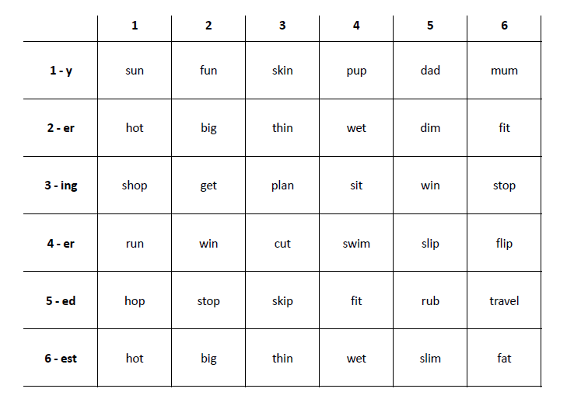
Times tables:
Please complete one page of your times tables booklet.
If you want to practise on times tables rockstars your log in details are in the front of your learning log.
Reading:
Please sign and date your reading record at least 4 times a week. Write the book title and how many pages/chapters you’ve read.

