Year 1 Phonics

Here are a few pointers to guide you in the right direction to enable you to best support the revision and progress of your child’s phonic learning whilst at home.

Letters and Sounds
http://www.letters-and-sounds.com/phase-4-resources.html
So far, we have worked through Phases 3 and 4 of Letters and Sounds so it will be useful to revisit and practise blending, and reading words, using these phonemes. The link above will take you to these resources and games which are all suitable.
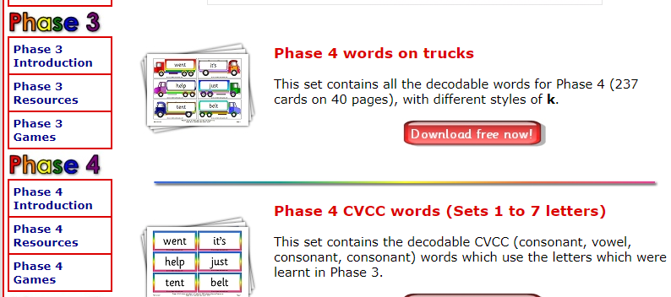

This is another good website with some additional activities to support revision:
https://www.cherrygardenprimary.co.uk/learning-zone/english/phonics/phase-3
Phase 3 overview
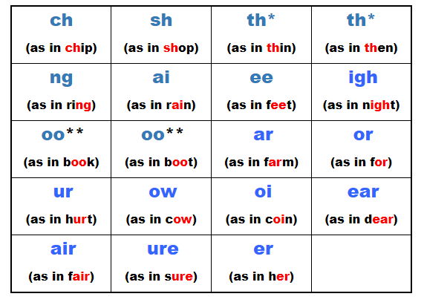
The activities (below) will appear on the right-hand side of the webpage and are all suitable – you will see this list and can click on them for paper based activities.
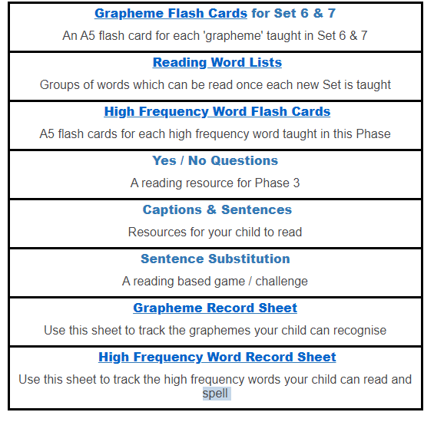
Phase 4 does not introduce any new phonemes but focuses on being able to use those known to blend in order to read new and unfamiliar words.
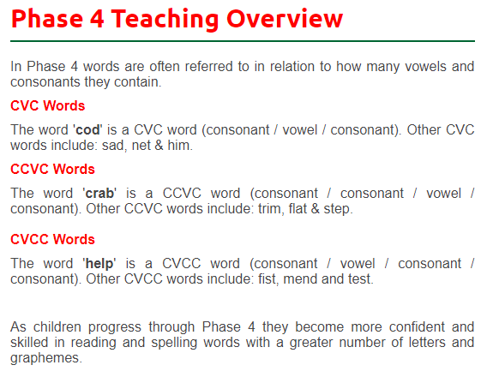

Once you feel that your child is confident with the reading, blending and segmenting for spelling of these phonemes then please move onto phase 5 which we have been looking at this term.
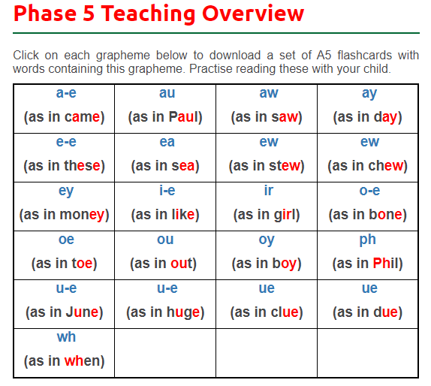
https://www.cherrygardenprimary.co.uk/learning-zone/english/phonics/phase-5

