Willow Home Learning – 30.03.20
I hope you are all well and are enjoying the beautiful weather and having the children at home. I’ve received some amazing messages from you showing me our children doing PE, cooking, writing, painting, going for Spring walks, making models. Please remember this is a menu for you to choose from; there is more here than you do in a week to enable choice so don’t try to do it all. There are so many brilliant resources online too. Try the fantastic White Rose maths materials (link below); each maths activities starts with a story. For songs and rhymes try BBC Schools radio (see below). I’ve included some easy science experiments at the bottom. I would like to receive one piece of learning each week by Thursday please and if you have anything you want me to include in your child’s learning journal please email a description and/or photos to me. scheney@bolneyprimary.school
For maths please try some addition and subtraction (see below). For English please try to write 2 sentences. A picture can be a good way to start. Read daily!
Take care and stay safe. Mrs Cheney x
Reading  Reading books for free.  https://www.oxfordowl.co.uk/for-home/find-a-book/library-page | Reading  Practise reading the keywords.  https://ictgames.com/mobilePage/dinosaurEggsHF/index.html | Daily – Audio Story  Join David Walliams online, reading a story a day at 11am:  https://www.worldofdavidwalliams.com/elevenses/ | Daily - Physical  Join Joe Wicks for “PE with Joe” at 9am: https://www.youtube.com/channel/UCAxW1XT0iEJo0TYlRfn6rYQ
Arts, Craft and Cooking  - Make a favourite recipe.  - Build a model (Lego Challenges below).  - Paint or colour a picture.  - Draw Challenge (see below). | Physical  - pencil control activities that will help with handwriting  https://www.twinkl.co.uk/resource/t-l-141-line-handwriting-worksheets | Speaking and Listening  Try singing nursery rhymes and songs, from BBC Schools radio  https://www.bbc.co.uk/teach/school-radio/nursery-rhymes-songs-index/zhwdgwx | Physical  - Try a Jump Start Jonny video  https://www.jumpstartjonny.co.uk/home
Phonics  - phase 3 phonics activities  https://www.twinkl.co.uk/resource/t-l-527192-phase-3-phonics-activity-booklet | Phonics  - phonics phase 2 word activities  https://www.twinkl.co.uk/resource/t-l-4185-i-can-read-phase-2-words-activity-sheet-pack | Phonics  - Add extra words to the yellow phonics word books, concentrating especially on the 2-letter digraphs.  - Can you add 5 words a day to your yellow book? | Phonics  - Practise phase 3 sounds, any phase 3 game.  https://www.phonicsplay.co.uk/PicnicOnPluto.html
Writing  - Write a letter (or stay home and email a photo of your writing) to Mrs Cheney  Bolney CEP School  Church Lane  Bolney  RH17 5QP | Writing  - Go on a spring walk and write 5 words that describe what you see and feel. | Writing  - Pick a favourite story and re-write it. | Writing  - Write a daily diary, 1-2 sentences a day about what you did the day previous or what you'll be doing that day.
Technology  - Use age appropriate apps and games such as Cbeebies:  https://www.bbc.co.uk/cbeebies/games?page=3 | Arts  A screening of the West End Show, Wind in the Willows, though they’re asking for a £5 suggested donation. https://www.willowsmusical.com | English  Amazing site that covers all aspects of the Early Years English Curriculum  https://uk.ixl.com/ela/reception | Writing – Once Upon a picture  Sometimes having a picture helps children get writing. I’ve included 2 pictures with questions below. You can ask the questions and there are writing ideas too.
Maths  - Add 2 groups of numbers together to make a number less than 10 and draw it. - Add 2 groups of numbers together to make 10 or a numbers up to 20 and draw it. | Maths  - Talk about taking away, about numbers getting smaller.  - Start with 10 and roll a dice, taking the number away from 10. Draw it. | Maths  - Counting to 20 game:  https://www.topmarks.co.uk/learning-to-count/helicopter-rescue | Maths  - Count items to 10 and  https://www.topmarks.co.uk/maths-games/hit-the-button
Maths  - calculation sheets - adding to 10  https://www.twinkl.co.uk/resource/t-n-2546524-number-shape-addition-to-10-activity-sheet | Maths  - addition to 20  https://www.twinkl.co.uk/resource/t-n-2546526-number-shape-addition-to-20-activity-sheets | Maths  - spring themed addition to 20  https://www.twinkl.co.uk/resource/spring-themed-counting-on-up-to-20-activity-sheet-t-n-7444 | Maths  - dinosaur subtraction from 10  https://www.twinkl.co.uk/resource/t-n-1445-dinosaur-themed-subtraction-sheet
Maths  Amazing Early Years Maths activities. Each starts with a story which is provided.  https://whiterosemaths.com/homelearning/early-years/ | Maths  Amazing site that covers all aspects of the Early Years Maths Curriculum.  https://uk.ixl.com/math/reception | Maths  - minibeast subraction from 10  https://www.twinkl.co.uk/resource/t-c-254592-minibeast-themed-subtraction-activity-sheets | Maths  - greedy monster take aways  https://www.twinkl.co.uk/resource/greedy-monster-taking-away-activity-sheet-t-m-31584
Science  - See the science experiments below (from Usborne 365 Science Activities). | Science  - Find out facts about a favourite animal from around the world. | Science  - Go for a Spring walk and draw what you notice | Science  - Keep a bean diary.
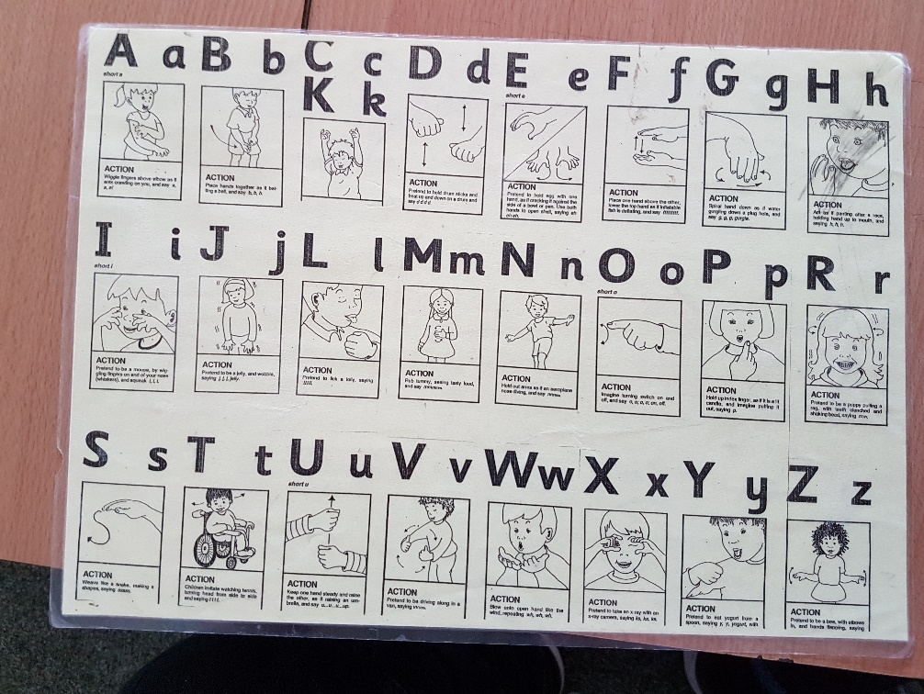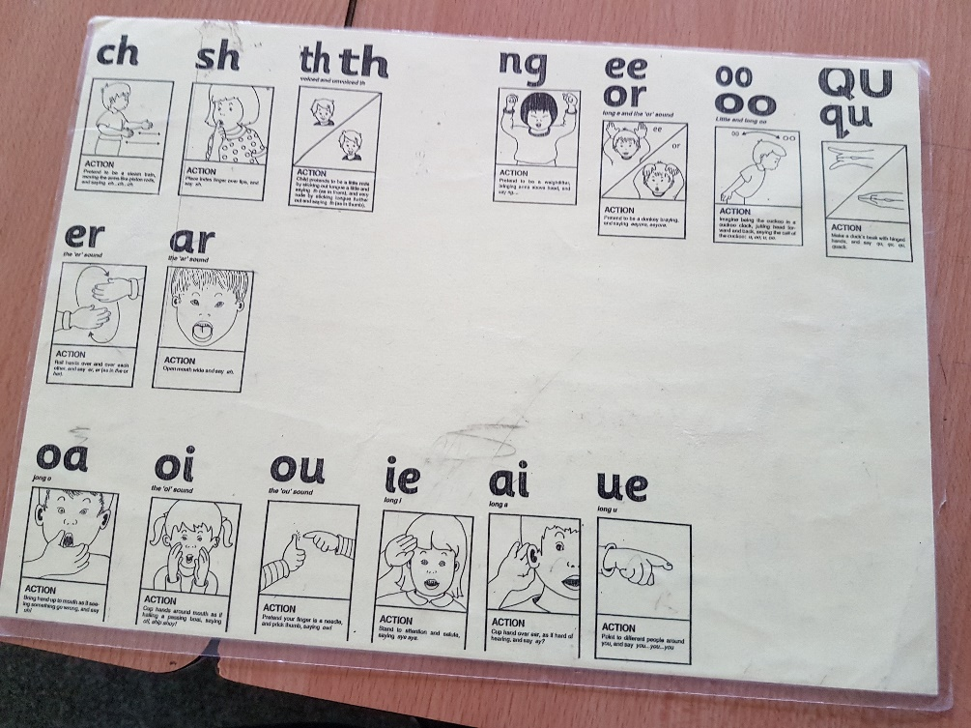
Science
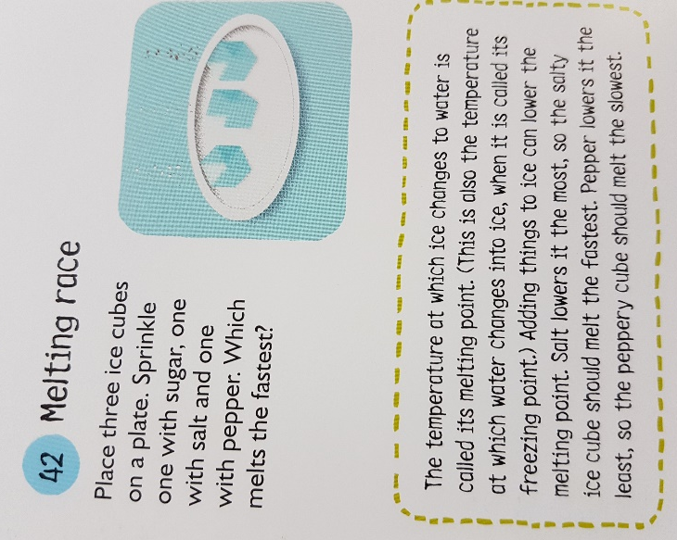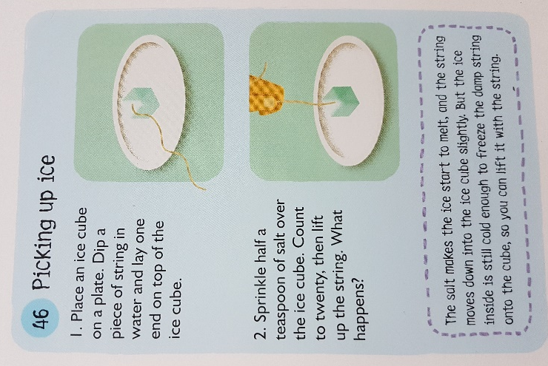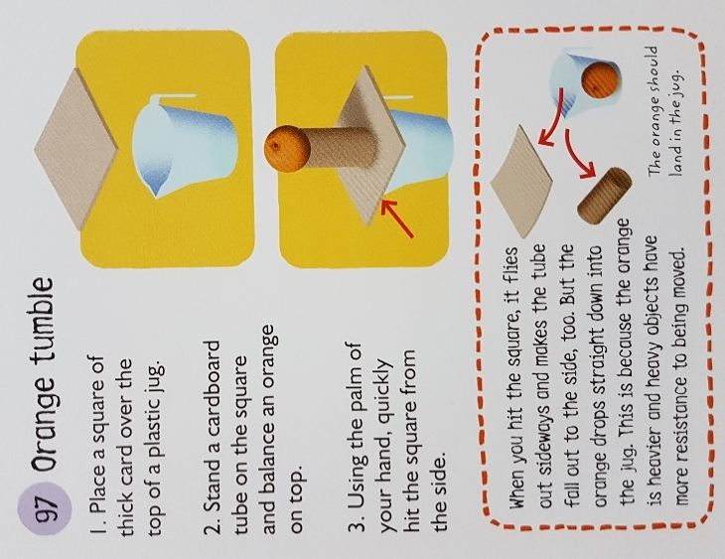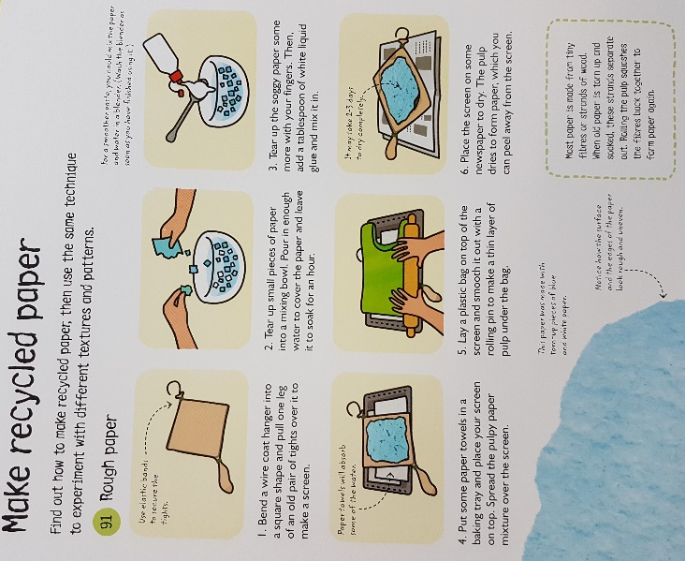
Once Upon a Picture
Enoki Tales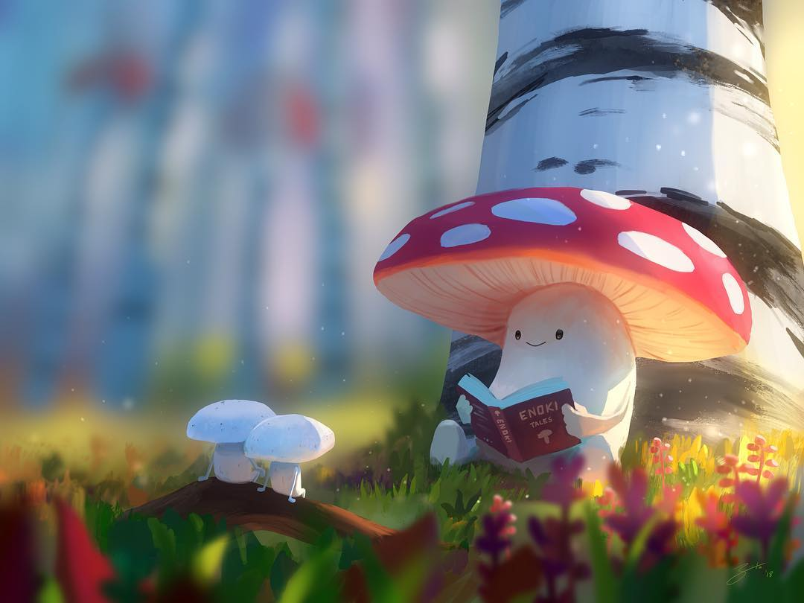 | Morning Surprise  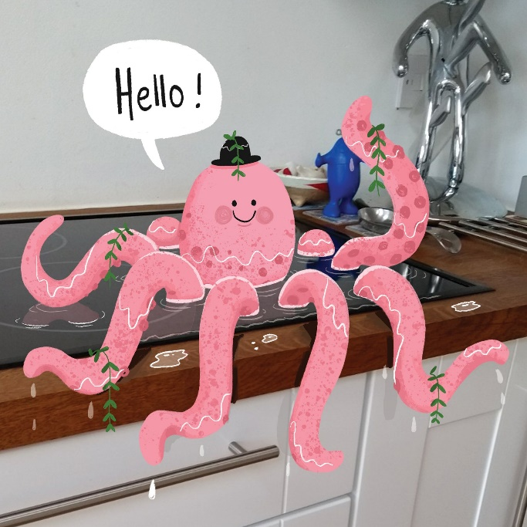
- What’s happening here?  - Do the two smaller mushrooms know the larger one?  - Have they done this before? How do you know?  - What is the larger mushroom reading? What kind of thing might you expect to find inside this book?  - ‘Enoki’ is the type of mushroom (it is the Japanese name for it, as it’s highly popular in Japan). Are the smaller mushrooms of the same species?  - What do you think might be in the background?  - Write a story that might belong in the book, ‘Enoki Tales’.  - Research the enoki mushroom. Find recipes including this food. Find out how not to confuse it with the Galerina marginata mushroom, and why this is important.  - https://www.onceuponapicture.co.uk/portfolio_page/enoki-tales/ | Imagine that you have just walked into your kitchen to find this. Choose:  - Role play the conversation you might have with the octopus.  - Role play the telephone call you might have with a friend or family member to tell them what you have found.  - You can only ask 3 questions to the octopus. What would you ask and why?  - You decide to let the octopus stay here, but the next morning you come into your kitchen to find it joined by another creature. What might it be?  - The telephone rings. It is the RSCPA and they are concerned: they have had reports from a neighbour that you are keeping sea life in your kitchen sink. What do you say?  - Try to persuade the octopus to leave. Then try to persuade it to stay. Which was easiest? Why?  - Write the story of how the octopus came to be here, and what happens next.  - Write a limerick about this picture.  - Questions:  - How did the octopus get here?  - Why is it wearing a hat?  - Is it speaking your language? Do you understand what it’s saying?  - Where did the plants come from?  - https://www.onceuponapicture.co.uk/portfolio_page/morning-surprise/

