BOLNEY C.E.P. SCHOOL

Church Lane, Bolney, Haywards Heath, West Sussex RH17 5QP
Tel: 01444-881352 Fax: 01444-881047
E-mail: office@bolneyprimary.school
Web: http://bolneyschool.org.uk/

Headteacher: Mrs Lorraine Kenny, BEd Hons, NPQH

Tuesday 23rd June 2020

Relationships and Sex Education

Dear Y5 parents,

I hope all is well with you and your family.

Normally, at this time of year, we deliver sessions to the Year 5 and Year 6 children on relationships and sex education as part of the science curriculum and personal, social, health and economic education. However, due to the current situation, we plan to deliver this in the autumn term to the current Year 5 children when we are, hopefully, back to ‘normal’ school.

In Year 5 we focus on puberty, physical changes, hygiene, relationships and growing up.

We understand that this important part of the curriculum covers some sensitive issues and so we will invite you to a meeting where we will show the materials we will use and answer any questions you may have before we deliver the sessions in the autumn term.

In the meantime, if you feel that your child may benefit from talking about any of this, we find these supportive books very clear and helpful, there is one for boys and one for girls.

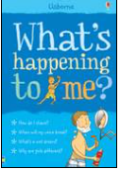
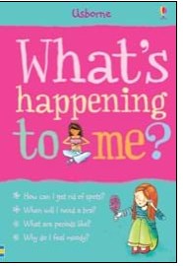

Kind regards,
Lorraine Kenny

