Week beginning: 23.3.20

Work to be completed at home:

English: You have created fantastic story plans after reading two versions of the story ‘Cinderella’. Now you need to tell the story to someone and then write it on the lined paper in the folder. Remember finger spaces, capital letters and punctuation and you will need to edit checking for sense and correct spelling. Use the word bank and phonic sheets to help you.

Phonics
Keep revising Phase 3 and phase 4 phonics – games and links can be found here:
https://www.cherrygardenprimary.co.uk/learning-zone/english/phonics/phase-3

http://www.letters-and-sounds.com/

Reading
Keep sharing quality picture books and continue with the Big Cat reading books included.

Common exception word spelling – how many of the words in your word folder can you spell?
Here is the list of Year 1 words you need to know:
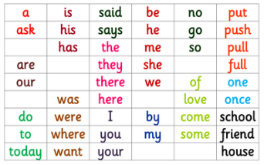

Maths:

Complete the nrich investigation sheet looking at measures

Time: telling the time to o’clock and half past plus. Continue to learn the days of the week and months of the year – can you order them and spell them?

Measures: investigate things that are long/short and heavy/light.

PE:
Joe Wicks will be doing some live workout sessions from Monday – who not take a look!
https://www.thebodycoach.com/blog/pe-with-joe-1254.html

Art:
Mark making on foil ahead of creating own Haitian style artwork for your initial letter of your name.
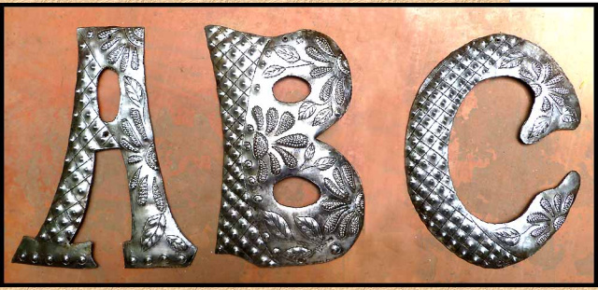

RE:
Revisit the Easter story – have you got a children’s bible? What happened during Easter week? Maybe you could draw this out?
This website has some lovely table place mats for discussion, download them here:
https://www.bathandwells.org.uk/supporting-children/youth-children/resources/bible-chat-mat/

Science:
Can you make a Spring collage out of natural objects? What are you noticing about this season? Perhaps take a photograph or draw it to remember it.

