Work to be completed at home by Friday 27th March:
It is expected that you work through all these activities throughout the week, where possible please. Please email work to me at mpitt@bolneyprimary.school
Anything that cannot be emailed can still be posted through the school letterbox.
If circumstances change we will look at other ways to send and receive work.
There are resources on the class pages on the website to help you – for example the calculation grids, topic grids and grammar tools/terms.
If you have any queries or you would like me to check things through please email me!
Mr Pitt
English:
Daily reading
Spelling: practise the double consonant rule – remember “double the consonant to keep the vowel short”
Grammar: can you improve these boring sentences by adding adjectives, fronted adverbials and conjunctions to build it up.
Boring sentence 1 - I was walking through the park.
Boring sentence 2 – The rabbit ran across the field.
Writing: Imagine you woke up one day to find this tiny dragon perched on the end of your bed.
Where did it come from?
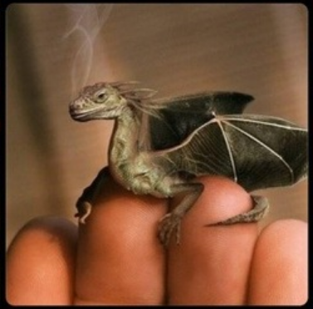
Task 1:
Write a description about your dragon – what does it feel like? What does it sound like? How does it move? Focus on the tiny details like its eyes, wings, scales and nostrils – can you describe them?
Task 2:
Look at animal fact pages and books.
Make up some facts about your dragon – how big does it get? How vicious is it? Where does it live? How many eggs does it lay? What colour are the eggs?
Task 3: Design a fact page to go in an encyclopaedia of animals.
Can you use conjunctions like – so, but, because, and, also
Can you use different sentence starters – “with a huge wingspan, this dragon is one of the largest in the world?”

Maths:
We looked at perimeter last week – can you explain what the perimeter is?
Can you measure the perimeter of your bedroom/kitchen/garden? You could do this with any measuring equipment you have or by using feet and counting the steps.
Can you draw a rectangle with a length of 8cm and a width of 5cm? Can you work out the perimeter of rectangles when some measurements are in whole metres and some are in centimetres?
2m
40cm

We would be covering area in class this week:
Area is the amount of space taken up by a shape.
We can work it out when shapes are drawn on a grid by counting the amount of squares inside.
This rectangle has an area of 15.
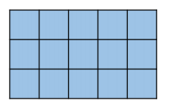
We would then progress to linking this to multiplication arrays. There are 3 rows of 5 squares. 3 x 5 = 15. We would also find the area of different rectilinear shapes by counting the smaller squares inside.

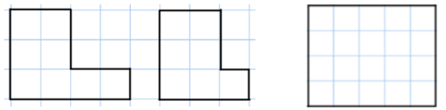

Please see attached sheet for maths tasks for the week.
TTRockstars/Hit the Button/Times tables practise to continue.
Science: Can you record the water cycle in action – where can you see evaporation or condensation?
Can you investigate changes of state – where can you see boiling, melting or freezing?
Can you make your own investigation – how long does it take for different liquids to boil? How long does it take for different things to melt?
RE: Discuss – how do Christians celebrate Easter?
What traditions are there? Does this differ in different countries/denominations?
Can you research and discuss?

Geography: We have looked at the countries of the UK. Can you choose a city to research?
How big is it? How many people are there? Where is it on the map? What makes it unique? Does it have sports teams, museums, interesting buildings? Are there rivers or mountains nearby? Are there any notable people from there (singers, athletes, scientists, artists etc)
Present your work as a fact page.
Art: We have recreated Hokusai’s The Wave and focused on perspective.
Could you practise these skills by drawing a view from your window or an imagined scene?
PE: How many star jumps can you do it 1 minute? How many burpees can you do? How many bounces of a ball? How many skips?
Can you set yourself a challenge and see if you can improve your scores each time?
Daily Mile: Can you make your own daily mile track around your garden or home?
Optional additional tasks:
Telling the time, counting and calculating with money and measuring are all everyday skills that can be practised at home.
Board games/card games/chess are good ways to develop strategy, counting and communication skills.
Cooking and measuring.
Gardening and caring for plants.
Looking after pets.
Helping around the house.
Joe Wicks will be using his youtube channel to teach home work outs.

Maths task
Explore area and perimeter by drawing different shapes on grids
What is the perimeter of these shapes? What is the area of these shapes?
What do you notice?
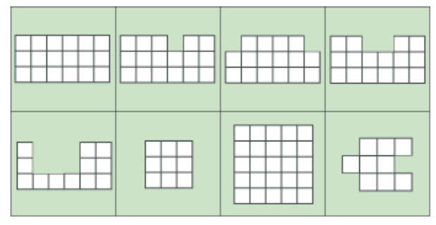
Can you draw a shape in which the area is numerically equal to its perimeter? And another?
Can you draw a shape in which the perimeter is numerically twice the area?
Can you draw a shape in which the area is numerically twice the perimeter?
Can you make the area of your shape go up but the perimeter go down?
Can you make the perimeter of your shape go up but the area go down?
Can you draw some shapes that have the same area but different perimeters?
Can you draw some shapes that have the same perimeter but different areas?

