**Safe place visualisation**

* Imagine a place where you feel calm, peaceful and safe. It may be somewhere you have been, want to go, dreamt about or made up.
* Focus on the colours in your peaceful safe place
* Notice the sounds or silence around you
* Think about any smells there
* Focus on skin sensations: the earth, the temperature, movement of air
* Give your safe place a name or word to bring it back. You can enter and leave your safe place whenever you desire.

**Encouraging Statements**

‘I may have some faults but I’m still a good person’

‘I care about myself and other people’

‘I accept who I am’

‘I love myself’

‘I embrace both my strengths and weaknesses'

‘Today I take responsibility for everything I say and do’

‘Each day I do the best that I can’

‘I’m a sensitive person who experiences the world differently’

‘Even though bad things happened to me in the past, I’m still a good person’

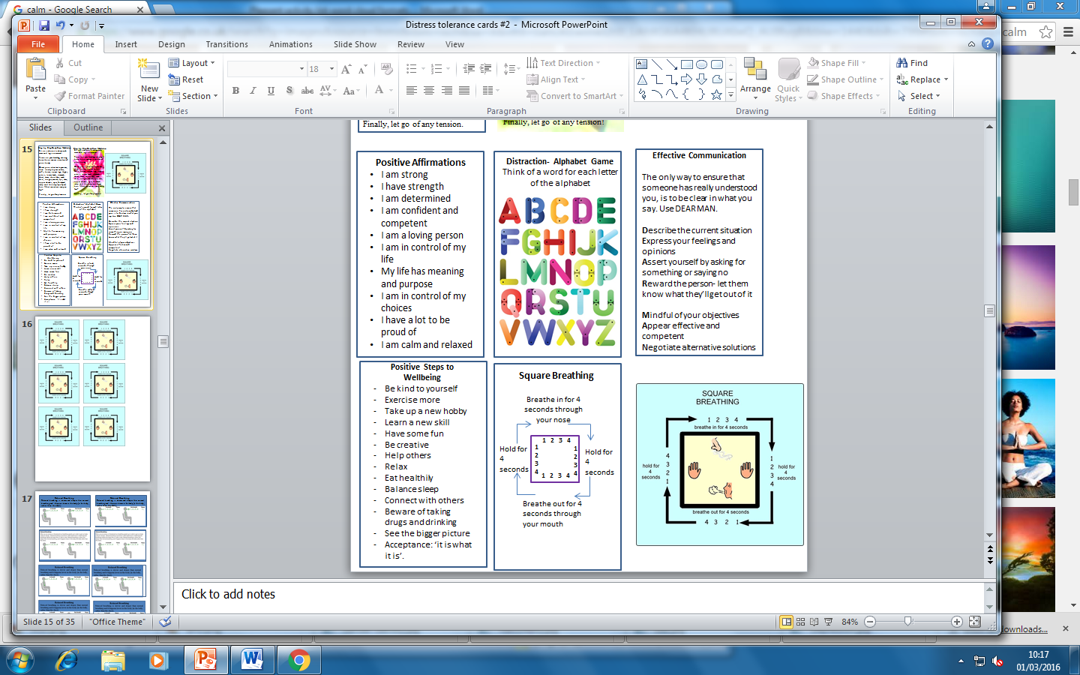  
  
  
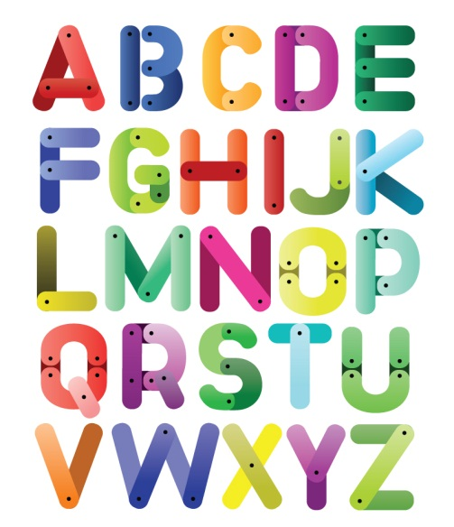  
  
  
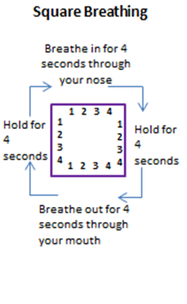  
  
  
  
  
  
  
  
  
  
  
  
  
  
  
  
  
  
  
  
  
  
  
  
  
  
  
  
  
  
  
  
  
  
  
  
  
  
  
  
  
  
  
  
  
  
  
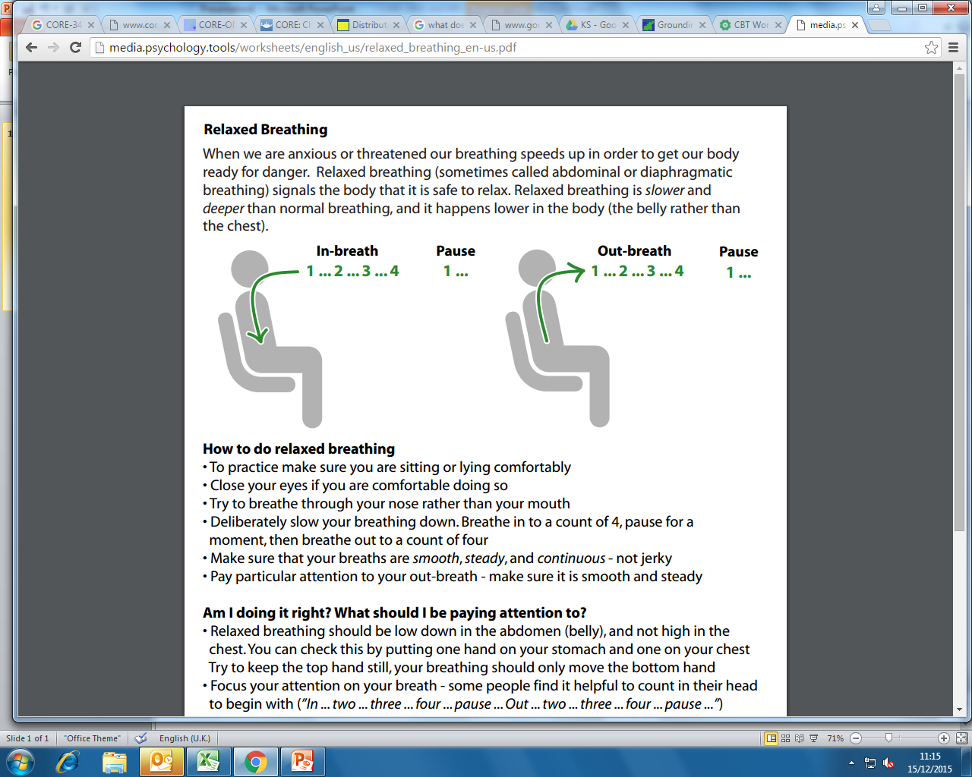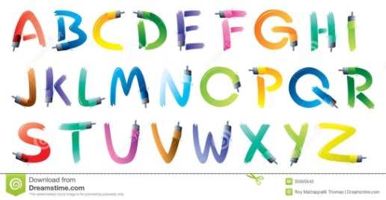

**Positive Statements**

* I am strong
* I am determined
* I am confident and competent
* I am a loving person
* I am in control of my life
* My life has meaning and purpose
* I am in control of my choices
* I have a lot to be proud of
* I am calm

**Positive Steps to Wellbeing**

* Be kind to yourself
* Exercise more
* Take up a new hobby
* Learn a new skill
* Have some fun
* Be creative
* Help others
* Relax
* Eat healthily
* Balance sleep
* Connect with others
* Practice mindfulness
* See the bigger picture

**Sensory Awareness**

Find a comfortable position.

Can you feel the *hair* touching your head?

Can you feel your *tummy* rising and falling as you breathe?

Can you picture something *far* away?

Can you feel the *bottoms* of your feet?

Can you feel the differences in *temperature* in the room?

Can you feel if one arm is more *relaxed* than another?

Can you imagine something very *pleasan*t?

Can you imagine *floating* in warm water?

**Encouraging Coping Thoughts**

‘This situation won’t last forever’

‘I’ve been through other painful experiences and survived’

‘My feelings make me uncomfortable right now but I can accept them’

‘I can be anxious and still deal with the situation’

‘I’m strong enough to handle what’s happening right now’

‘This is an opportunity to learn how to cope’

‘It’s okay to feel sad, anxious or afraid sometimes’

‘My thoughts are like clouds in the sky, they’ll pass’

‘I’m not in danger right now’

**Step-by-Step Body Scan Meditation**

Sit on a chair or lie down with arms and legs uncrossed.

Focus on your breathing, noticing how the air moves in and out of your body.

Direct your attention to your toes, then slowly to your ankles, calves, knees, upper legs, thighs, pelvis, lower back, stomach, chest, arms, shoulders, neck, chin, tongue, mouth, lips, nose, upper cheeks, eyes, forehead, scalp and the very top of your hair. What sensations can you feel?

Finally, let go of any tension.

**Distraction- Alphabet Game**

Think of a word for each letter of the alphabet

**Skill: Self-Soothing**

VISION: Look at the stars, look at pictures you like, buy a flower, go to a museum, look at nature, go to the beach.

HEARING: Listen to soothing music, pay attention to sounds around you, turn on the radio, sing a song.

SMELL: Use your favourite shampoo or perfume, bake biscuits, walk in a wooded area and smell nature.

TASTE: Eat some of your favourite foods, chew gum, suck a sweet.

TOUCH: Take a long shower or bath, pet your dog or cat, get a massage, put comfy clothes on, wrap up in a blanket.

**Distracting activities**

**Activities** – Focus attention on a task, go to an event, play a game, go for a walk, play/watch sports, go for a meal or read.

**Contributing** – Volunteer, help someone, connect with others.

**Emotions** – Read a book/magazine, watch a show or a film, listen to music or the radio.

**Mindfulness** – breathing, walking, colouring or eating.

**Nature** – go to the beach, local park or plan a trip where you can immerse yourself in nature.

**Thoughts** – Count to 10, repeat words to a song.

**Sensations** – take a shower, squeeze a rubber ball, hold ice in your hand.

**IMPROVE the Quality of the Moment**

**I**magery – Imagine relaxing scenes or that everything is going well.

**M**eaning – Find purpose or meaning in a painful situation.

**P**rayer – Ask for strength to bear the pain.

**R**elaxing – Take a bath, drink hot milk, massage your neck, breathe deeply.

**O**ne thing - Focus your entire attention on one thing and keep yourself in the moment.

**V**acation – Give yourself a break- read a magazine, go for a walk.

**E**ncouragement – Cheerlead yourself : ‘I will make it out of this’ and ‘I’m doing the best I can’ and rethink the situation.

**STOP! - Take a helicopter view**

When something is upsetting us, we can be too close to be able to see the whole picture. Taking a step back allows us to be less emotionally involved and see different perspectives. Ask yourself:

**SELF:** What am I reacting to? What does this situation mean to me?

**OTHERS:** What would this look like to others involved?

**OUTSIDER:** How would this seem to someone outside of the situation? How may they respond?

**WISE MIND:** What would be the best thing to do for myself and others in this situation?

**Distraction Techniques - Alphabet Game**

Pick one of the ideas below and think of an example for each letter of the alphabet:

Food , Names, Something you can see, Films, Musician, Plants, Animals.

**Grounding Techniques**

‘54321 Game’

Name **5** things you can **see** in the room with you

Name **4** things you can **feel** (e.g., chair on your back, feet on the floor).

Name **3** things you can **hear** right now (e.g., birds singing, traffic going by)

Name **2** things you can **smel**l right now

Name **1** thing **good about yourself** (e.g., I have completed this exercise)

**Grounding Techniques**

Re-orient yourself in time and space by asking yourself these questions:

*Where am I?*

*What is the date today?*

*What is the time?*

*What is the year?*

*How old am I?*

*What season is it?*