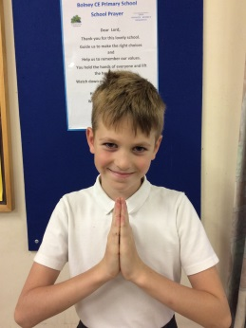  Dear Lord, | 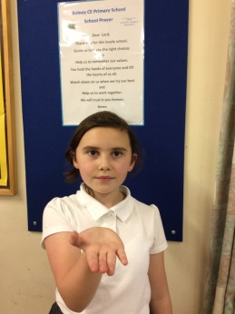  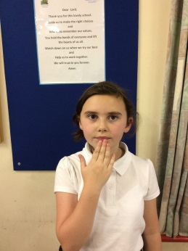  Thank-you for this lovely school. |  |  | 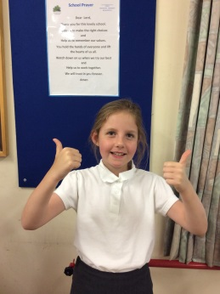  Guide us to make the right choices and
Help us to remember our values. |  | You hold the hands of everyone and lift the hearts of us all.
Watch down on us when we try our best and |  |  | Help us to work together. We will trust in you forever.  Amen

