Week beginning: 30.3.20

Work to be completed at home Year 1:

To all the year one children
I hope you are all getting on well with learning at home and keep up your brilliant learning.

Parents please can you help your child share one piece of learning with us each week – this can be work they have completed using a computer or a photo of it. Please email this to me, by Thursday – sharvey@bolneyprimary.school, or drop it at school if you are able to go for a walk.
You can also email me if you have any questions.

Mrs Harvey

English

Writing: Write a set of instructions for someone in your house to follow. Perhaps ‘How to brush your teeth’ or ‘How to play the card game SNAP’ or ‘How to plant seeds’ https://www.youtube.com/watch?v=2mBR1hb6c2A

Phonics: Review our recent work on split vowel digraphs. (Letters and Sounds, Phase 5)
Here’s a reminder of what they are: https://www.youtube.com/watch?v=_IlBA-b5tzk
Choose a picture book and play detective looking for examples of split digraphs words. Can you reach 10?

Reading: Choose a simple rhyme and see if you can learn it off by heart. There are some ideas on the link below if you’re struggling to think of one!
https://www.booktrust.org.uk/books-and-reading/have-some-fun/rhymes/

Common exception word spelling – keep working on them, focus on 5 per week.

Here is the list of Year 1 words you need to know:
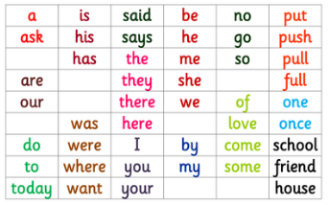

Maths

Mental Maths
Choose from Addition, Subtraction or ordering numbers – I recommend you start at Level 1
https://www.topmarks.co.uk/maths-games/daily10
Please work on number bonds to 10 and then extend to 20. This can be done as creatively as you like…pebbles, ladybird spots, buttons etc or via the link above where you can find this screen:
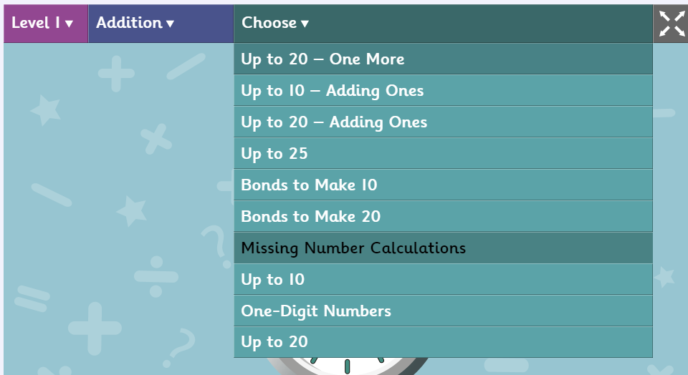

Place Value
Place Value Basketball helps children to understand the concept of hundreds, tens (‘chips’) and ones (‘peas’).
https://www.topmarks.co.uk/learning-to-count/place-value-basketball

PE:
Enjoy being outside!
Try some Yoga and Meditation
https://www.cosmickids.com/category/watch/

Art:
In this Live Lesson, hosted by Cbeebies presenters Joanna Adeyinka-Burford and Ben Cajee pupils are guided through fun drawing exercises with the help of Pablo Art Director Bob Price.
Children learn how to recognise different facial expressions and emotions before being encouraged to draw their own character in the style of Pablo.
https://www.bbc.co.uk/teach/live-lessons/cbeebies-pablo-live-lesson/zn7ty9q

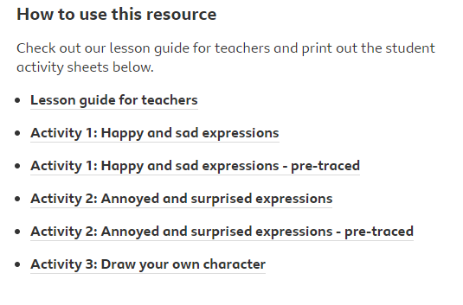

RE:
Remember the story of The Good Samaritan? https://www.bbc.co.uk/bitesize/clips/zcyr87h
Think about how you can be a good neighbor whilst staying at home.

We all have people at home who we can help: maybe with homework, or playing with little brothers and sisters, or doing household chores (even the ones you don’t like!) In our neighbourhoods, we might have old people living in our roads who at this time are feeling alone. We might not be able to visit them, but as a family, you might be able to help them by getting them some shopping because they’re not able to go out themselves….. Or if you can’t do that, maybe you could write them a letter or draw them a picture to let them know that you are thinking of them and to cheer them up…
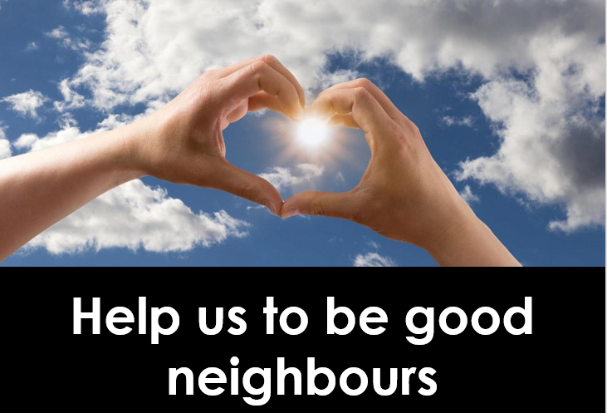

Science:

Please sign up to Explorify (FREE!) there are some wonderful clips and photographs that can be used for discussion at home. Take your pick depending on what interest you!

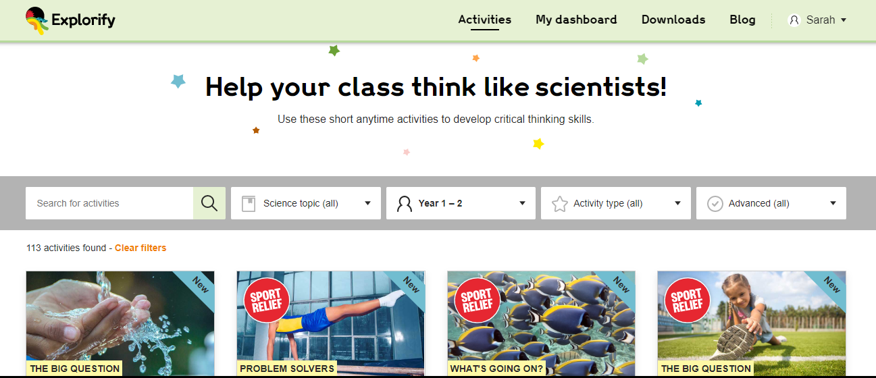

Look after each other, stay safe and be happy!

See you soon,
Mrs Harvey

