Holly - Monday 30th March – Friday 3rd April:
Here are a range of activities and learning for this week. We are aiming to provide a range of work covering lots of different areas. We are also aware that it is a lot, so please work through in your own time and order. Please do not feel rushed to complete absolutely everything if this is not possible!
Please send one example of work you have been doing this week by Thursday 2nd April – this can be pictures or in whatever format is most convenient. If you are still able to drop it off at school this is also a possibility.
Please email me if you have any questions at mpitt@bolneyprimary.school
There are resources on the class pages on the website to help you – for example the calculation grids, topic grids and grammar tools/terms.
Mr Pitt
English:
Daily reading – it is nice to read a range of books (fiction and non-fiction), you may want to read to a pet or a sibling. You may want to write a review to keep track of all the books you have read while at home.
Writing:
Task 1: Choose a job that needs doing round the house or an activity with lots of steps involved. It could be baking, caring for houseplants, keeping your room tidy, feeding, caring for and tidying up after a pet.
Do the job! You might want to take pictures of each step as this will be useful later…
Task 2: Look at the instructions for how to make a bird feeder.
You could make the feeder if you have the resources to. Discuss how it makes the steps clear and how it is organised to help you get it right.
Task 3: Write instructions for the chore or activity you chose.
Try to include:
- a list of materials or ingredients
- clear steps in the right order
Grammar and punctuation we would aim to cover in class -
- ‘bossy’ verbs at the start e.g ‘mix flour and eggs’, ‘whisk together the ingredients’
- prepositions and adverbs at the start of sentences e.g. firstly, then, next, after a while
- descriptions to help explain ‘beat the mixture until it is light and fluffy’
- conjunctions to help organise – and, because, so, also,
- commas, full stops, bullet points
Spelling:
Plurals ending in f, ff, fe.
Most plurals just have an s added to the root word e.g. 1 cup or 2 cups.
Rule: If a word ends in ‘f’ or ‘fe’ then we don’t just add an ‘s’, we change it to ‘ves’
e.g. knife becomes knives, scarf becomes scarves.
If the word ends in ‘ff’ we do just add an ‘s’ e.g. cliff becomes cliffs
Task: Can you change these to the plural - half, leaf, scarf, cliff, knife, wife
Write sentences with the plural version of the words.
Can you find any exceptions to the rule?
Maths: Continue focusing on area and perimeter.
Children would be asked to write using the units e.g. cm, m, mm and are introduced to the vocabulary ‘squared’ and the notation cm² – because we are measuring the space covered in square units.
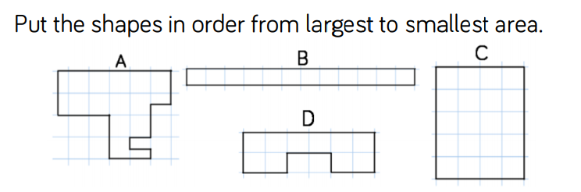
Task 1: Be careful with this one – how many whole squares are there in each shape?
What will you do if there is only part of the square covered?
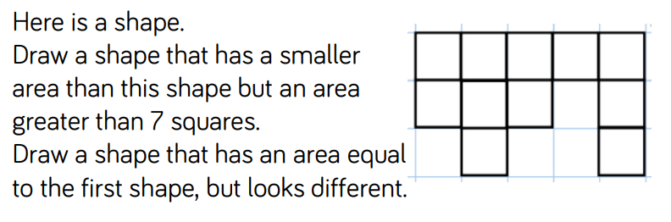
Task 2:

Task 3: Complete these area problem solving questions.

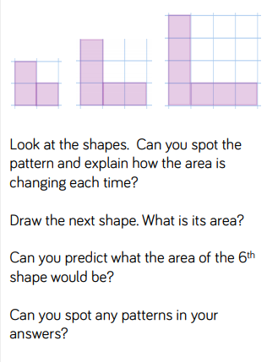
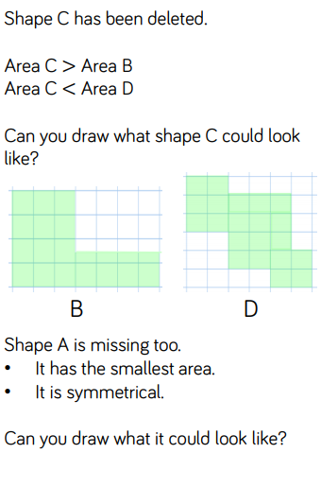

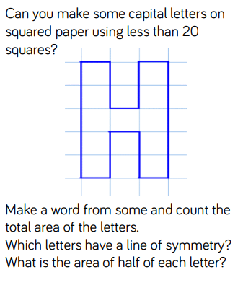

Mathsbot is a great online resource to use for drawing shapes – use the ‘geoboards’ feature under the ‘manipulatives’ feature.
TTRockstars/Hit the Button/Times tables practise to continue.

Science: What if water couldn’t freeze? Imagine what it would be like – discuss with someone at home.
Can you think of a good thing about this?
Can you think of a bad thing about this?
Consider these questions:
What would happen to polar bears, penguins and other wildlife reliant on ice?
How would you make your drinks colder during summer?
What would happen to snow during winter?
What would happens to seas and oceans?
Here is a great resource to recap the water cycle.
https://www.natgeokids.com/uk/discover/science/nature/water-cycle/
A great practical and fun activity involving ice:
Can you build a skyscraper using ice blocks? How tall can you build it? What problems do you find?
You could research igloos to find out how ice can be used as a building material

RE: look at this picture of ‘The Last Supper’ – what does this picture show? Who stands out in the picture? Can you spot Judas?
Why is the last supper so important to Christians? How is it remembered today? What does the wine and bread represent?
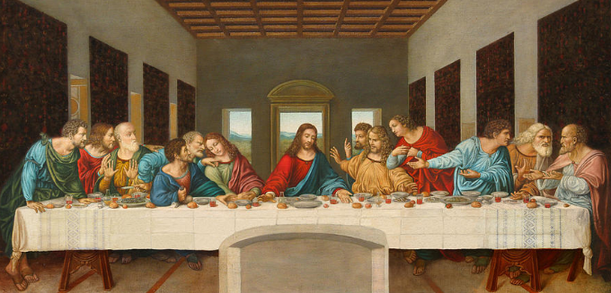

PE: How many star jumps can you do it 1 minute? How many burpees can you do? How many bounces of a ball? How many skips?
Can you set yourself a challenge and see if you can improve your scores each time?
Daily Mile: Can you make your own daily mile track around your garden or home?
Check the website for ideas and resources from Mid Sussex Active.

Geography:
Research the climate of the USA.
Can you find out about these cities and areas: New York - New York, Houston - Texas, Seattle - Washington, New Orleans – Louisiana, Omaha – Nebraska.
What are the cities like – how many people? What is there to do? What sports teams and entertainment venues are there?
What is the weather like? Are there any mountains, lakes, rivers?
Do they face extreme weather – like drought, floods, hurricanes, tornadoes or blizzards?
Compare the UK city you have looked at last week – what do they have in common? What is different?

Optional additional tasks:
Telling the time, counting and calculating with money and measuring are all everyday skills that can be practised at home.
Board games/card games/chess are good ways to develop strategy, counting and communication skills.
Cooking and measuring.
Gardening and caring for plants.
Looking after pets.
Helping around the house.
Joe Wicks will be using his youtube channel to teach home work outs.
Keep some recycling materials around for junk modelling.

