Work for Silver Birch – Week beginning 30th March 2020

Hello all!
Well this has certainly felt a very bizarre week! I hope you have all been ok and made the most of being in the sunshine (from the safety of your gardens of course!). It is safe to say that school just isn’t the same without all of you in it. I am missing you very much! Below is some more home learning for this week. I have heard from people that have done slightly different things – and that’s ok if there is something you would really like to explore.
Please share one piece of your learning with us each week – this can be work you have completed using a computer or a photo of it. Please email this to myself or leave it at the school office if you can still go out for a walk by Thursday of each week: rburton@bolneyprimary.school Over the Easter holidays you can send me either any learning or a fun thing you have done. Please ask your parents for help with this if you are unsure how to do it.
Here are my home learning recommendations:
https://myminimaths.co.uk/
This has lot of daily tasks on it if you want to practise some calculations.
https://www.youtube.com/watch?v=kRt5Mk6V8Gg
Mrs Harvey sent me this link to a CBBC series on evacuation – it looks really good!
I am still more than happy for you to email me if you have any questions or queries at rburton@bolneyprimary.school . Please be patient for a reply as, as you can imagine, there is a lot to being seeing to currently and I want to take the time to reply to you as fully as I can.
On the Silver Birch class page, there is the calculation progression showing the methods we use of this (if you wish to practise your methods in additional to the work set). I have also uploaded the SPAG grid which explains all the grammar features across the curriculum.
Topic Grid – I have uploaded the previous topic grid back to the website. I will leave this up as there are quite a few!
Maths – TT Rockstars can be used to keep up with your tables!
Have a look at this problem:
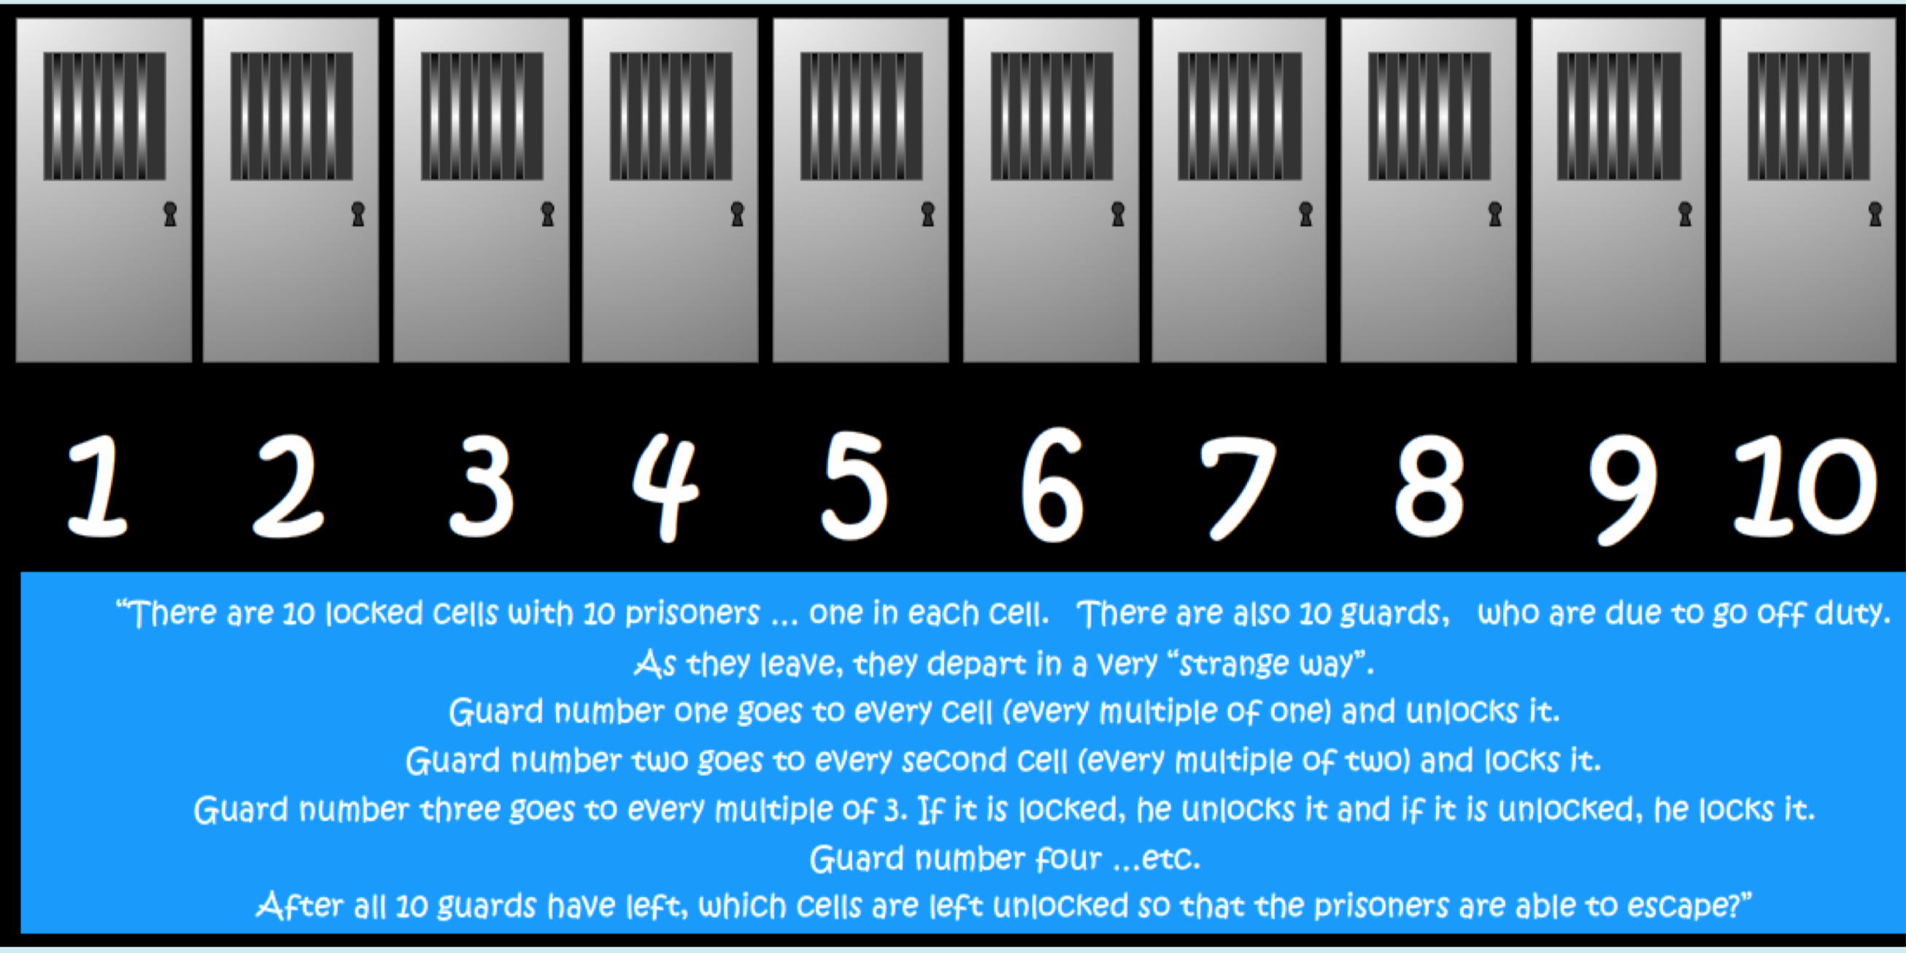
As you can see, this problem is promoting your multiples knowledge. Have a go at solving this problem showing your water-tight explanation as to what the correct answer is before creating one of your own. Again, you could send it to someone else to solve!
You could also visit: https://whiterosemaths.com/homelearning/ and look at your year groups’ home learning.
Year 5 – Decimals
Year 6 – Ratio
Each lesson has a short video and then an activity to support.
English – Please continue to read daily. It would be good to film yourself reading a section of the book you are reading and send it to someone in the class – it might inspire them to read your book too!
I had great fun watching this video: https://www.literacyshed.com/pigeon-impossible.html I couldn’t stop giggling. There are a range of things that you could do in response to it:
- Write more missions for Walter which are spoilt by the pigeon,
- Write a news report on events, interviewing key witnesses etc.
- Write a persuasive argument giving an argument for why it was not the pigeon's fault.
- Should we feed the pigeons in the street? Discuss.
You may choose which one you would like to do. Please select three skills off of the SPAG grid that you are going to focus on practising.

Science – We would have been finishing our light unit this week. I would like you to refer back to our big question: What can you see when there is absolutely no light?
Using what you have learnt and, conducting your own research, I would like you to try and answer this question as fully as possible.
You may refer to:
- How light travels
- How the eye works
- How we see colours

RE – We have begun to explore the question of ‘Why was Jesus resurrected?’
Here are some more things to discuss at home
Talk about what kinds of songs or readings might be used at someone’s funeral. Why might these songs be chosen?
Think about fictional characters, such as Buzz Lightyear or Wall-E, or Bart Simpson. Think of popular songs or perhaps scenes from films pupils know that would suit those characters.
Decide what kinds of things need to be said or communicated at a funeral, and why.

Computing – Hopefully some of you will have downloaded Kodu at https://www.kodugamelab.com
In this link, https://www.kodugamelab.com/resources/ there is a whole series of lessons that you could begin to work through. You need to click on the links for the resources. Obviously, you don’t need to follow these lessons if you have managed to explore quite a lot already and you are happy to continue to do this.
If you have been on scratch, it would be good to see if you can create a game. Some ideas can be found here: https://scratch.mit.edu/studios/437422/
Daily Mile – Please find time for 10/15 miles to have a walk outside (even if it is just in the garden).
PE - Joe Wicks will be using his YouTube channel to teach home workouts. Please see the link here: https://www.youtube.com/user/thebodycoach1
Another thing you could do is set up an obstacle course, time yourself completing it and then see if you can improve your time.
Music – Have a listen to the ten trailblazers on here: https://www.bbc.co.uk/teach/ten-pieces/ten-pieces-trailblazers/zfpy7nb
Think about what instruments you can hear, describe the pitch and tempo and then rank the pieces from your least favourite to your most favourite.
Optional additional tasks that you may have ongoing as a project.
- Playing games (card games, board games etc)
- Sewing
- Cooking – following a recipe
- Gardening
- Accurate measurements (including conversions)
- Time (read bus and train schedules and plan a journey if you are being creative)
- Complete a project on a subject of your choice

