Science:

The circulatory system  
- describing the function of the blood, heart and blood vessels

- the heart  
- arteries, veins and capillaries  
  
- heart rate & physical fitness  
- investigating the impacts of exercise and rest on heart rate

- healthy lifestyles – recognizing the impact of diet, exercise, drugs and lifestyle on the way bodies function

PE:

Circuits  
Netball/Basketball skills

Art:

Clay snakes, hieroglyphics & cartouches, Canopic jars

**The Egyptians**

RE – Understanding Christianity

God - What does it mean if God is holy and loving?

English:

Key texts: Pharaoh’s Fate & Secrets of a Sun King.

Outcomes: fact page, formal letter, formal report, narrative

Maths:

Place value, addition, subtraction, multiplication, division, factors, multiples, prime numbers, BODMAS and number sense.

Computing:

E – Safety

Using garageband to program music

PSHE:

Jigsaw – Me in my world  
Zones of Regulation

History:

* What did the Egyptians believed happened after death?
* What was daily life like for the ancient Egyptians?
* Why was the Nile so important? (Geography links)
* Why and in what ways were the Egyptians so advanced?

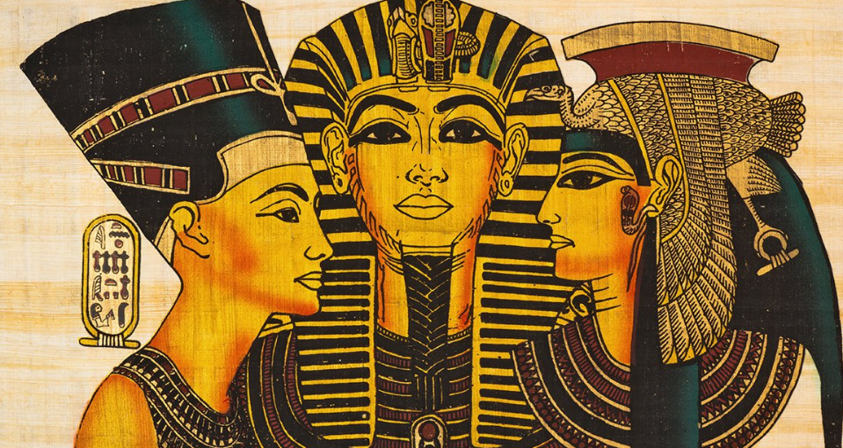

Skills Covered in English

Writing –

Various Spelling Rules

Sentence types

Word Classes

Planning

Editing and Proof Reading

Fronted Adverbials

Prepositional Phrases  
Formality  
Persuasive writing  
  
Descriptive writing  
Engaging the audience

French – Vanessa Samedi

Music

Music programming using GarageBand.