Silver Birch – remote learning w/c 4.1.21
I’m sure that wasn’t the start to term we were hoping for. Please remember you can email me if you are worried or struggling with anything.
Here is the learning for the rest of this week – to be completed remotely or in school.
Please do not feel obliged to complete absolutely everything if this is not manageable.
It would be really helpful if you could email me an update by the end of the week to let me know how you are getting on. This does not have to be completed work or pictures, it could just be an email to tell me what you have been doing and how you have found things.
Next week remote learning will be accessible via Microsoft Teams. Teachers will be uploading videos to accompany this. You should be receiving your log in details for this shortly.
Mr Pitt
Maths:
Prime numbers!
Last term we looked at prime numbers – a number (other than 1) that can only be divided by 1 and itself.
Task 1: This is a good way to practise the bus stop method too (you could use a calculator for the first couple of calculations if you need!)
Take the number 6,469,693,230 and divide it by the first prime number.
Take the answer and divide it by the second prime number. Continue this process until you have reached the tenth prime number. What number do you end up with?
Task 2: Take the number cards:
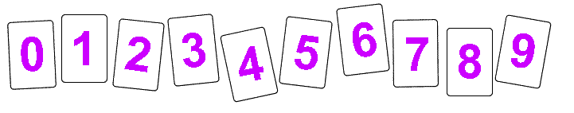
Can you arrange them to make some prime numbers?
See how many you can make.
Challenge:
Try making 5 two digit prime numbers – use each card once.
Can you do it with 1 one digit prime, 1 three digit and 3 two digit prime numbers.
This is really tricky! You could use this list of prime numbers and try combinations.
https://www.mathsisfun.com/numbers/prime-numbers-to-10k.html
Think about what numbers cannot go in the ones column and why.
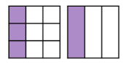
Fractions – We begun looking at equivalent fractions this week e.g. this shows that 3/9 is equivalent to 1/3 and 3/12 is the same as 1/4.

Task:
Using the digits 0, 1, 2, 3, 4, 5, 6, 8
Can you make equivalent fraction pairs? E.g. I could use 2, 5, 1, 4 and 0 to make 2/5 = 4/10
How many pairs or groups can you find?
Challenge:
Can you find an equivalent pair where one denominator is 30? Can you find an equivalent fraction pair where one denominator is 20?
English:
Grammar –
Recapping different word classes – nouns, adjectives, verbs, adverbs etc. The SPAG grid is useful for going through terms and practising some sentence level work. This can be found on the class pages on the website.
Recap phrases and clauses – what are they? What is a relative clause? (clue: who, which, that, whose)
Writing – Watch the Viking sagas video – Odin creates the world.
https://www.bbc.co.uk/teach/school-radio/english-ks2-viking-sagas-1/zrnd92p

Write a description about what you imagine Asgard or Jotunheim looked like.
You might like to watch the videos, research further and draw what you can imagine first.
Although we often now describe Jotunheim as being home to the giants – the Vikings were not totally clear on who/what exactly lived there. Some say they are more like trolls!
Write a short story – perhaps from the point of view of the mischievous Loki – who needs to travel across Midgard, Jotunheim and Asgard. Where is he going? Who does he encounter?
Think about the Viking style of stories – full of action, exaggeration, heroes, monsters and fighting!
If you prefer – you could present this in a comic book style. Try and include a mixture of story description in boxes, some speech and illustrations.
Topic – Research Yggdrasil and the 9 worlds. What is it and what is its significance?
Can you compare this idea to religions or belief systems you already know about?
You could produce some artwork inspired by it.
You might find this link useful - https://kids.britannica.com/students/article/Yggdrasil/314289

Computing – Use flipanim - https://flipanim.com/ to create a flipbook style animation.
You can use different pens/brushes and colours to create images. You can then put these images in an order to tell a story/create a moving character. You can decide whether you want your images to move quickly or slowly.
You could try and make a moving Viking ship or a warrior wielding an axe or something completely unrelated to the Vikings…
PSHE – Produce a poster explaining the different zones of regulation.
What characteristics can describe each zone?
You might want to include tips to help people move from the red, blue or yellow zone into the green zone.

