English

Our key texts are the ‘Journey’, ‘Quest’ and ‘Return’ trilogy by Aaron Becker. We will be writing travel guides for the fantastical city, diary entries from different perspectives and imaginative stories about epic journeys.

We will also be writing to inform and explain, particularly when focusing on our natural disaster topic.  
  
Our grammar focuses are on developing sentence structures, incorporating different clause types, selecting different ways to start sentences and using different conjunctions to join ideas.

**Holly – Spring Overview**

**What a Disaster!**

Art & DT  
  
perspective and fine art techniques

PE  
Dance  
Swimming  
Hockey

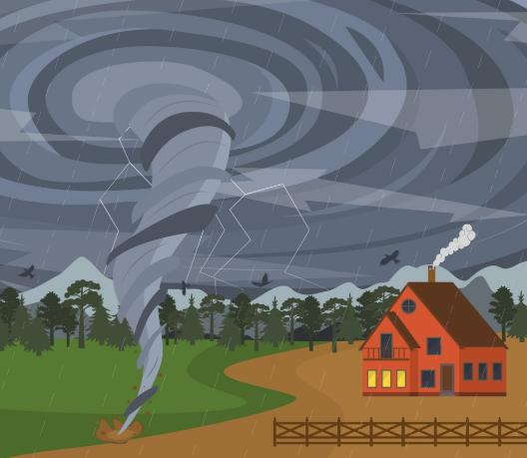

Topic:  
  
We have a geography focus this term. We will be learning about the causes of natural disasters such as wildfires, earthquakes, tornadoes, hurricanes and floods. We will be discussing the impact of these events on humans, animals and the wider world as well as what can be done to address these issues.

RE  
We will be finishing our unit on Baptism and the Trinity before moving on to studying Judaism

Maths

We will focus on fractions and decimals for the majority of the term. Y3 will work on representing fractions, identifying fraction equivalents and tenth – decimal equivalents. Y4 will work with mixed numbers and hundredths as well as this. We will also find fractions of amounts and solve problems involving all of these areas. We will then move onto area and perimeter and properties of shapes.

Science

States of matter is our first science topic. We will identify and discuss properties of solids, liquids and gases as well as work scientifically during investigations.  
This leads us on to learning about the water cycle and our key question – where does a puddle go?

Music

Young Voices  
concert  
Three Little Birds

Computing

E – safety  
Coding