Good Morning!

Here is some work for you to do while at home.

- Please continue daily reading. Especially those all-important discussions about the books with parents.
- Your times table booklets
- If you were not here at the time, please complete a diary entry about one of the days at Kingswood. If you were here, you are more than welcome to do another.
- We are beginning poetry based on the sinking of the Titanic. Have a think about some poetic devices or description which would include:
- Similes – Comparing something to something else (e.g. as tall as a sky scraper)
- Metaphors – Saying something is something else (e.g. A wave of terror washed over him)
- Personification – Giving an object human features (the clock sang it’s song)
- Onomatopoeia - Words that sound like the sound it makes (crash, smash etc…)
- You could have a go at creating some diagrams of some electrical circuits that either work or don’t and explain why. Think back to all the sabotage work you did!
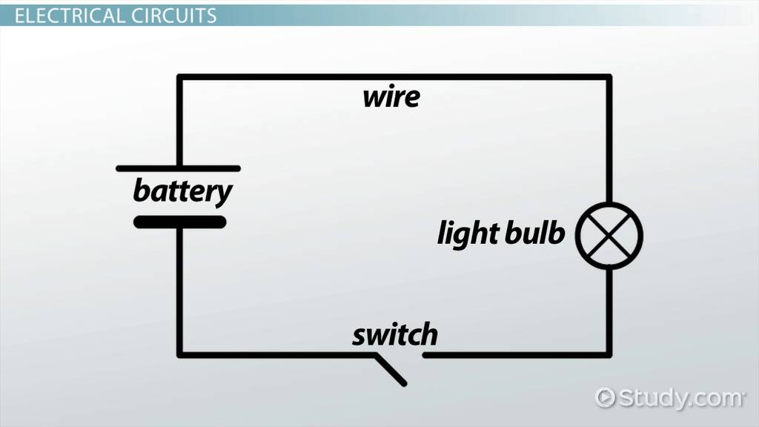
- You could practise your 3D letter skills that you have been doing with Mrs Wood

Hopefully see you soon!

Mrs Burton

