**Week beginning: 30.3.20**

**Background information and objectives to support you**

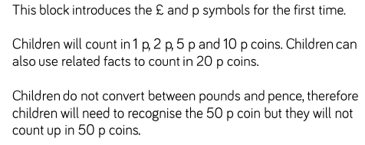

**I know the different coins and I can compare amounts.**

**1)**

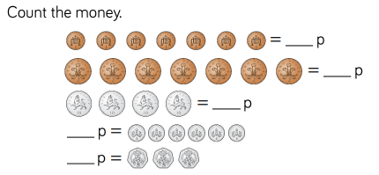

**2)**

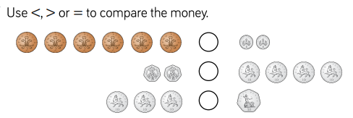

**3)**

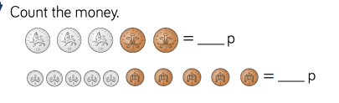

**Possible questions to ask whilst completing the tasks**

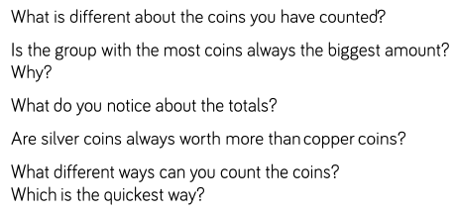

**Reasoning and problem solving with money**

**1)**

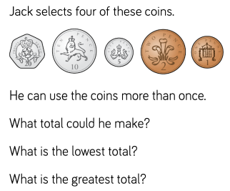

**2)**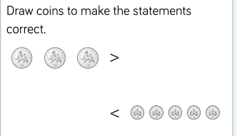

**Next block of learning objectives/notes to help you**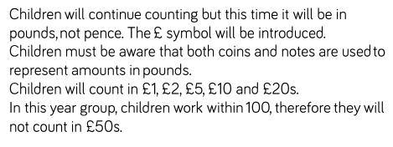

**Possible questions to ask whilst completing the tasks below:**

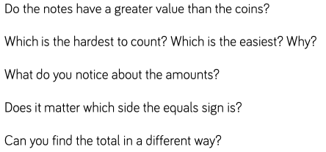

**1)**

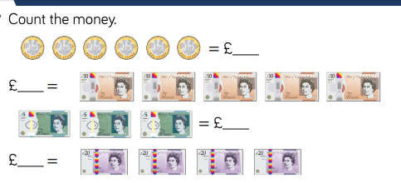

**2)**

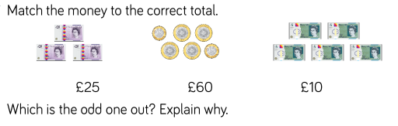

**3)**

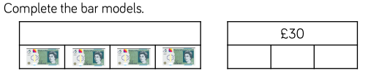

**Reasoning and problem solving**

**1)**

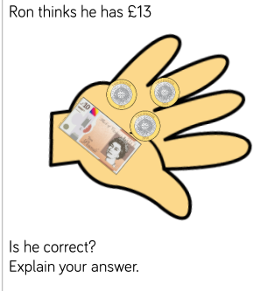

**2)**

