Trips/Special events

Showing Sunny (Our surprise guest) around our village

Drusillas Park (13.1.20)

Chinese New Year China Day (24.1.20)

Art/DT

Haitian metal work

African Kalahari Desert Collage

World map collage

P.E

Gymnastics

PSHCE and Character Matters

Working as a team

Getting along

Challenges

**Here, There and everywhere!**

English

Our focus is Non Fiction and writing to inform

Key Texts:

Meerkat Mail

My Granny Went to Market, a round the World counting text

Meet the Meerkat

Let’s Celebrate, Festival poems from around the World

First News

The Week

National Geographic Meerkats

Usbourne Children’s Atlas

At the same moment around the World

Maths

We will be focusing on the following areas:

Time, place value and money.

We will also be incorporating problem solving as a way of strengthening these mathematical skills. Reasoning and deepening concepts remain a constant focus.

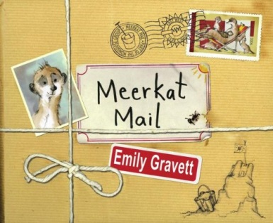

Science

Weather - climate around the World

Seasonal changes from Winter to Spring

Habitats and how animals and plants depend on each other to survive

Geography/History

Looking at maps/aerial views

Planning a journey

Identifying continents and countries

Researching the cultures of other countries

Design our own flag (Paint)

Currencies of the world

Clare James and Sarah Harvey

January/February 2020

Year 1/2

R.E

Why is the Torah important to Jewish people?

Different faiths around the World

Music

Music from around the world looking at pitch and timbre

Computing

Using Microsoft Word

Using Swiggle and Google to research countries and continents

Explain Everything app and Adobe Spark Video