**Holly – Autumn Overview**

**The Stone Age**

RE

Our big question is ‘What do Christians learn from the Creation story?’

Art & DT

Cave art style paintings  
Making dens.

PE  
Football  
Team games  
Netball

Science

Digestion is our focus in science. We will be learning about the key organs and body parts involved in the process as well as the impact of healthy and unhealthy diets.

Maths

We will focus on place value, rounding, counting and mental arithmetic strategies as well as formal methods for the four calculations.

English

Our topic this term is the Stone Age. Our key text are ‘Woolly Mammoth’ by Mick Manning, ‘Stone Age Boy’ by Satoshi Kitamura and ‘The Wilderness War’ by Julia Green.

We will be researching and writing fact pages about Mammoths, we will be re-enacting the story of the ‘Stone Age Boy’ and learning about Stone Age life before writing stories.

Our trip will be to Butser Farm.

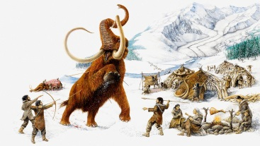

Music

Singing

Musical notation

Computing

E safety  
Editing images and presentations.