Willow Class
Year R Home Learning Pack
Spring 2021 Week 2 – week commencing Monday 11th January 2021
Change Makers/Enchanted Woodland
Dear Parents and carers,
Welcome to week 2 of lockdown learning. Please find below some ideas of activities you can try and these can be completed at home or at school. I hope these are useful.
I am aware that we all have different circumstances; not everyone has access to a printer or device for running apps. You don’t want your child looking at a screen all day. Please let me know what works and what you need as well as anything that’s proving difficult and I will try to adapt.
- Keep reading! That means read to and with your child, not necessarily school books – just keep reading, more than anything else!
- Practice reading and writing keywords (see the list below).
- Do practical stuff; cook and bake together. Get outside and take exercise! Most importantly try to stay safe and well and just have a go. You know your child better than anyone!
I am posting this new homework with videos on Teams and on the class pages. Please let me have a piece of English, Maths and Topic work by Monday each week, as photos of their work posted through Teams. Please email if you have any queries: scheney@bolneyprimary.school
Let me know if there is anything I can help with.
Take care and stay safe, lots of love, Mrs Cheney

Reading
Send me a photo of the books you’ve read this week.
Which was your favourite?
English – Writing
Woodland Animals
How many Woodland Animals native to the UK can you name?
I could think of 11 when working with friends in school. Can you beat that?
You will need this list next week when we move on to fact writing.
Please share this with me on Teams!
Science
Winter Weather Diary
Keep a Winter Weather Diary. Watch the Shirley Hughes Video clip, Cold.
Practice writing the days of the week.
Write down what the weather is like each day.

Senses Walk
Go for a walk in the woods. Use your senses and draw and write what you can:
- See - Hear
- Touch - Smell
Stay safe and make sure you don’t eat things you find. Make sure you wash your hands after your walk.
Please share this with me on Teams!
Maths – Counting from 0 to 5
This week we’re developing our understanding of 0 and practising comparing numbers.

Watch the Numberblocks episode about zero:
https://www.bbc.co.uk/iplayer/episode/b0blsx34/numberblocks-series-3-zero

Draw me a picture that shows comparing objects including zero.

Please share this with me on Teams!
Show Me!  Encourage the children to show numbers with their fingers, including 0. Ask,  “Show me 3 fingers.”  “Show me 5 fingers.”  “Show me 0 fingers.”  “Show me 2 claps.”  “Show me 1 claps.” | Comparing  Share snack onto 2 or three plates. Share a small number between the plates and ask,  “Do we have the same?”  “Is it fair?” “Have you got more?”  “Who has got more?” Who has got less?”  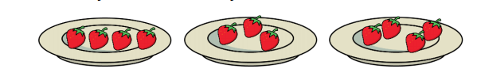
English – Phonics
Phase 2
Watch the Phase 2 Phonics clip, a chance to recap some of the sounds we’ve already learned.
Read the words with me and then try writing the words that go with the pictures.
Write your name and get a grown-up to take a photo.

Please share this with me on Teams!
Phonics Resources
www.phonicsplay.co.uk/resources/phase/2
The Phonics Play website has brilliant resources for all phases and some of the activities are free.

www.bbc.co.uk/iplayer/episodes/b01cz0p1/alphablocks
I love Alphablocks!
TV Resources
CBBC TV
www.bbc.co.uk/schedules/p00fzl9r/2021/01/11
From Monday 11th January CBBC is programming sessions to support primary education
on CBBC, starting at 9am Monday to Friday.
My favourites are Deadly 60, Operation Ouch and Celebrity Teacher!

Joe Wickes YouTube Kids Workout
https://www.youtube.com/watch?v=6oIorMNtw5g
Joe Wickes is doing his daily workout for kids again, starting from Monday 11th January at
9am on his YouTube channel.
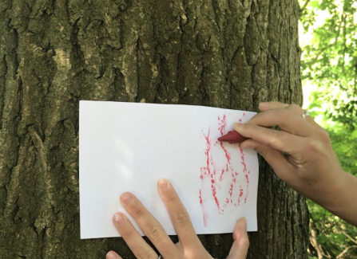
Science - Tree Barks
Hold a piece of paper over the bark of a tree and rub a crayon or pencil gently rub the bark.
Try doing this to 3 different trees.
Can you find out what type of trees they are?

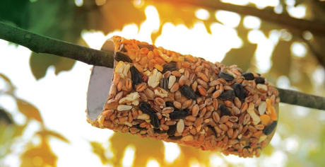
Science - A loo roll bird feeder
Messy but fun!
In 2 weeks time we can take part in the RSPB Great British BirdWatch.
You might like to start feeding the birds to encourage them and it will help you learn about the birds where you live. You can make this simple bird feeder:
1. Cover a cardboard tube in peanut butter (no added salt and sugar versions are best for birds).
2. Roll it in bird seed and thread some string through the hole.
3. Tie it up in your garden where birds will feel safe eating.

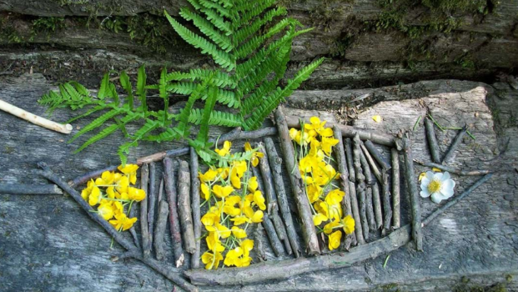
Creative - Make nature art
Use natural materials like leaves, petals and sticks and use them to make a picture or sculpture. Please make sure you don't pick wildflowers, however, as they are important for wildlife and some are protected by law.
Wellbeing Tips from Mrs Harvey
Activity
Learning when to take time to breathe can you feel happier and more comfortable.
Practice this easy technique a few times until you feel relaxed.
1. Think about a colour that makes you feel happy – this is the colour of good feelings.
2. Think about a colour that doesn’t make you happy – this is the colour of your not so good feelings.
3. Now close your eyes and take a deep breath in, imagine the breath is the good colour.
4. Now breathe out and imagine it is the not so good colour and blow it away, out of your body.
KS1 Story – Under the Same Sky
https://www.bbc.co.uk/iplayer/episode/m000hsff/cbeebies-bedtime-stories-750-tom-hardy-under-the-same-sky
Well-being tip:
Be sure to get enough sleep! How many hours do you think you need?
https://www.nhs.uk/live-well/sleep-and-tiredness/how-much-sleep-do-kids-need/

