Holly – Friday 13th March 2020
Reading:
Please sign and date your reading record at least 4 times a week. Write the book title and how many pages/chapters you’ve read. Please also write the date.
Spelling:
This week we have revisited taught spelling patterns from earlier in the year. We have discussed strategies for spotting mistakes when we are writing such as reading ours sentences backwards one word at a time starting from the end, looking at the part of the word that looks wrong, trying different vowel spellings and writing them out in different ways to see what look right.

Can you proof read the section below – it has double consonant, tion words, homophones, prefixes and suffixes to correct.
Extension: You could write a section with lots of mistakes in like this for us to try in class next week.
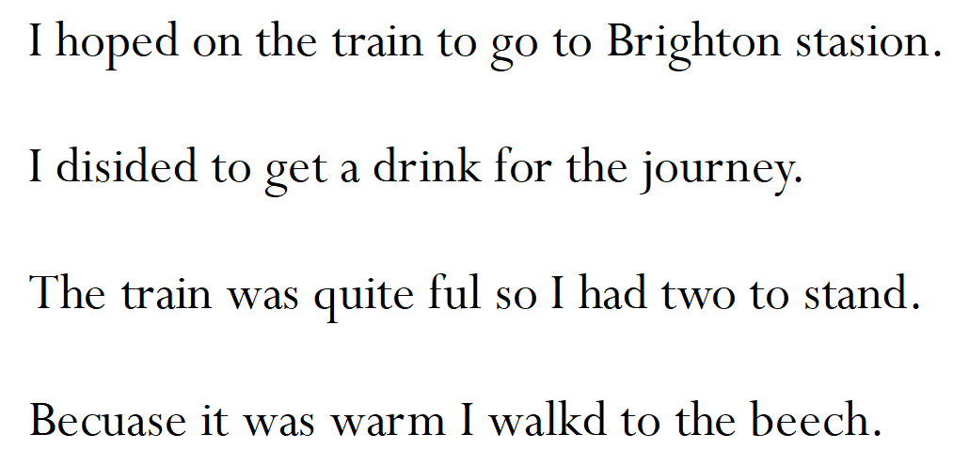

Times tables:
Please complete one page of your times tables booklet. Please remember to write the date in the box at the top of the page.
If you want to practise on times tables rockstars your log in details are in the front of your learning log.

