LO: To translate shapes and understand how shapes are transformed by translating (HA)
1. Here is a quadrilateral on a square grid.  The shape is translated so that point A moves to point B.  Draw the shape in its new position.  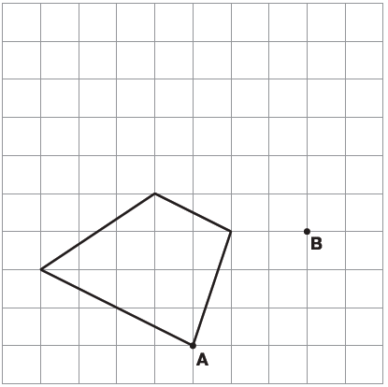  Describe HOW the shape has been translated (units up/down/left/right etc? ___________________ | 2. Here is a triangle on a square grid.  The triangle is translated so that point A moves to point B.  Draw the triangle in its new position.  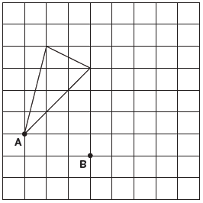  Describe HOW the shape has been translated (units up/down/left/right etc? ___________________
3. This irregular hexagon is translated so that point A moves to point B. Draw the shape in its new position.  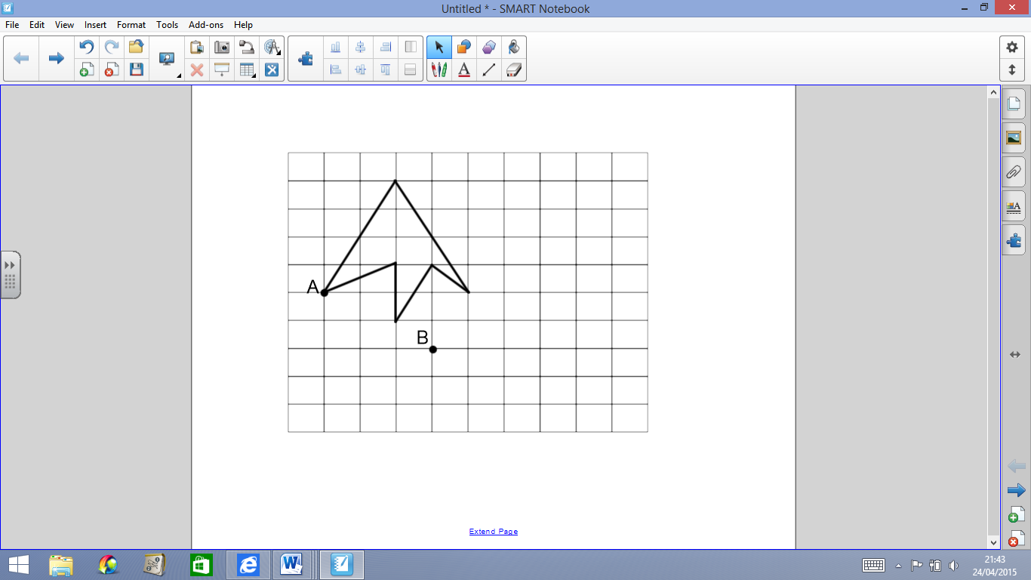  Describe HOW the shape has been translated (units up/down/left/right etc? ___________________ | 4. This irregular decagon is translated so that point A moves to point B. Draw the shape in its new position.  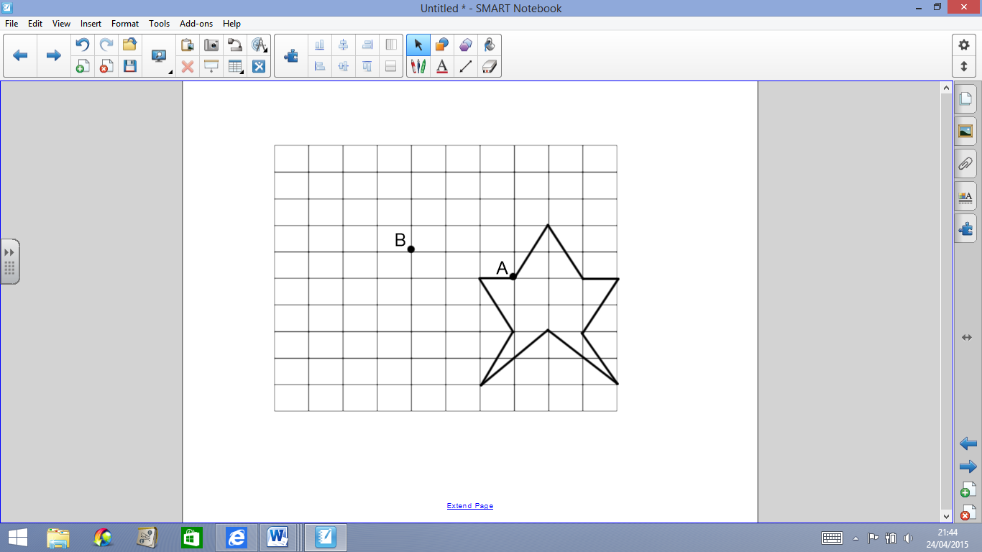  Describe HOW the shape has been translated (units up/down/left/right etc? ___________________
5. This irregular hexagon is translated so that point A moves to point B. Draw the shape in its new position.  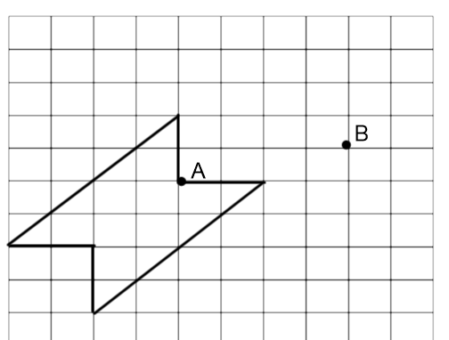  Describe HOW the shape has been translated (units up/down/left/right etc? ___________________ | 6. This irregular dodecagon is translated so that point A moves to point B. Draw the shape in its new position.  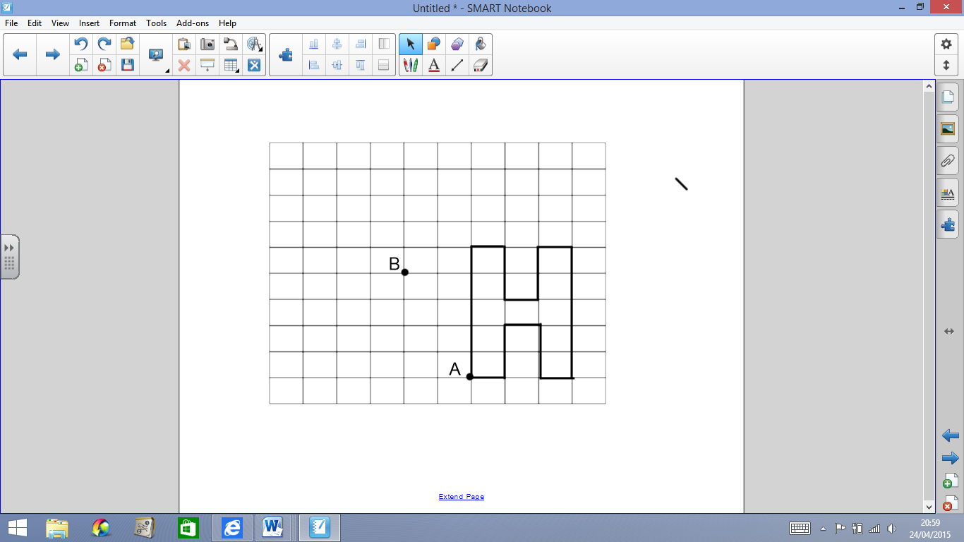  Describe HOW the shape has been translated (units up/down/left/right etc? ___________________
7. Translate this triangle 5 units right and 4 units up.  What are the co-ordinates of the corners in the new position:  A:________  B:________  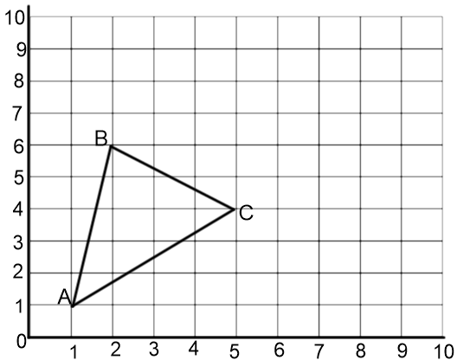  C:________ | 8. Translate this trapezium 3 units left and 5 units down.  What are the co-ordinates of the corners in the new position?  A: _______  B: _______  C: _______  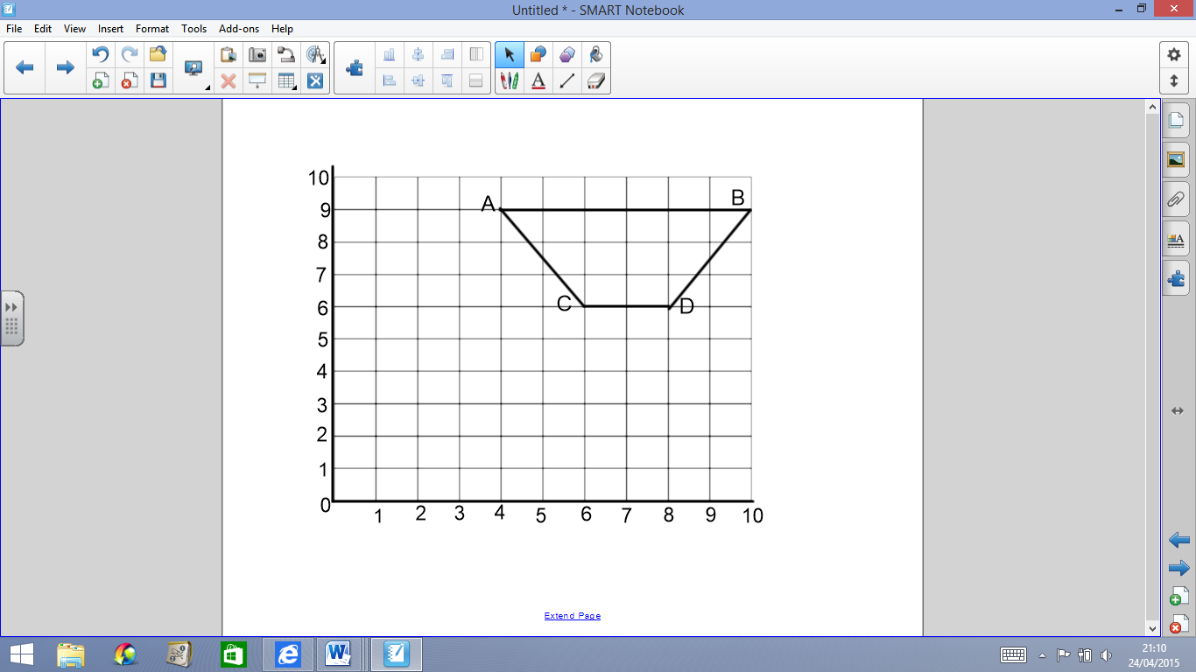  D: _______

9.
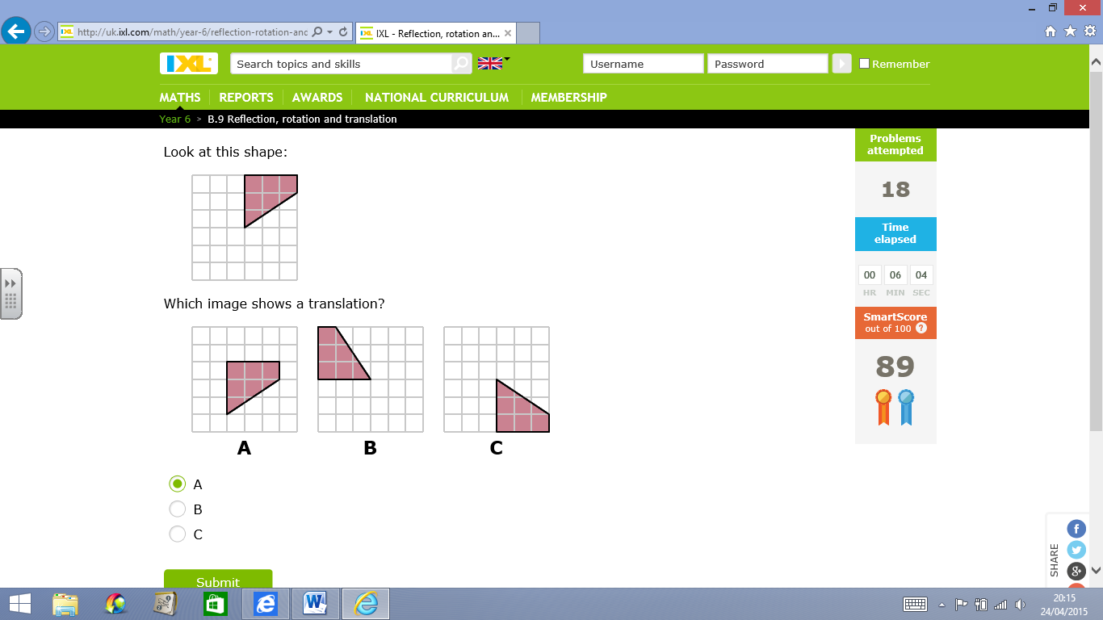
The answer is: ______
Describe HOW the shape has been translated. How many units left/right/up/down?
___________________
10.
The answer is: ______
Why isn’t it the other 2 pictures?
It isn’t ____ because
_____________________
_____________________
It isn’t ____ because
_____________________
_____________________
_____________________

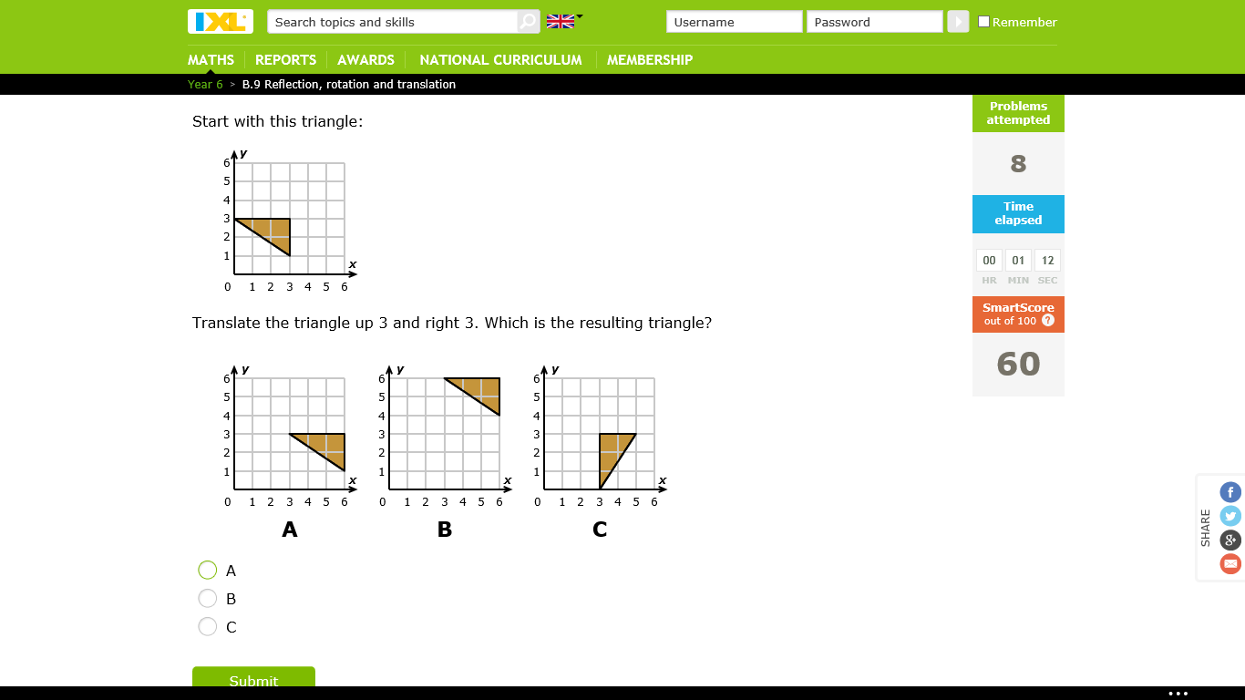

11.

Describe how the triangle on the left, has been translated to create the diagram on the right:
_________________________________
_________________________________
__________________________________

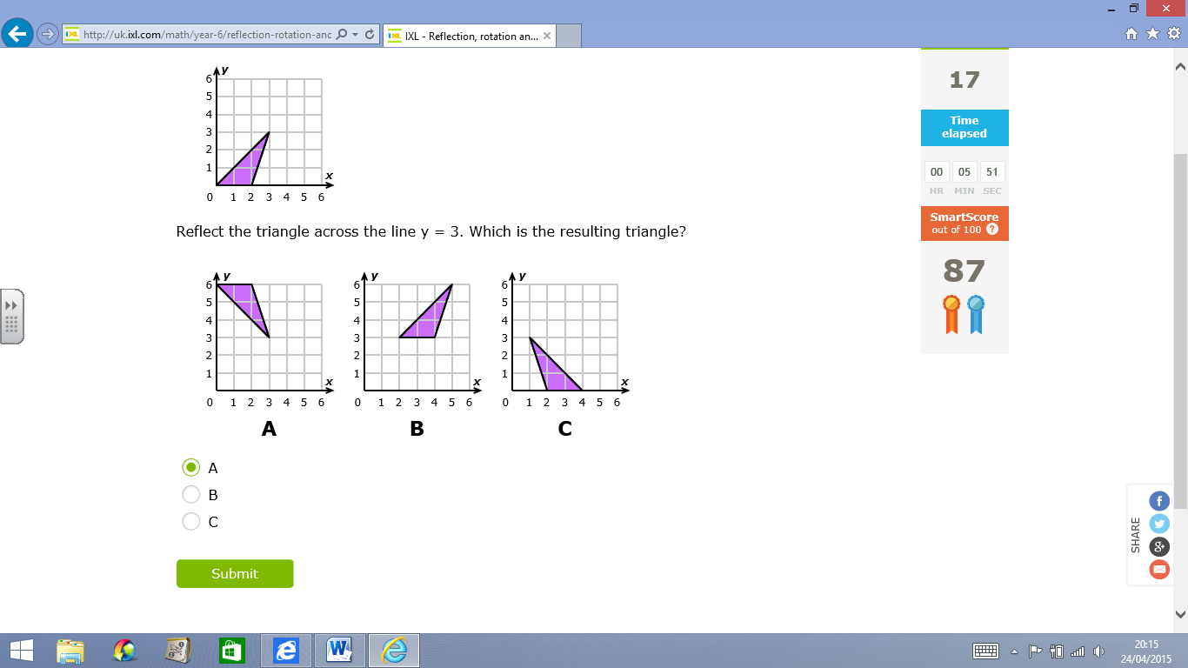
12.
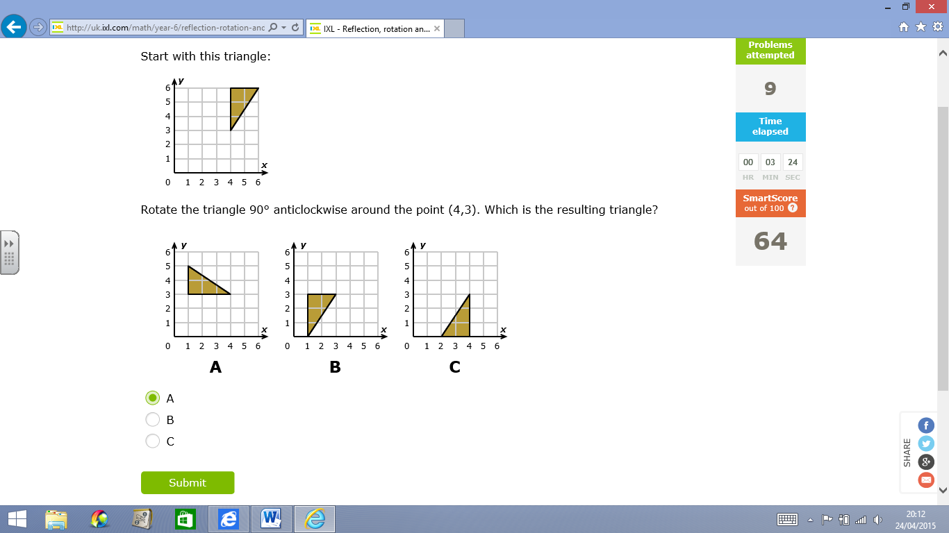

Describe how the triangle on the left, has been translated to create the diagram on the right:
_________________________________
_________________________________
__________________________________

13.  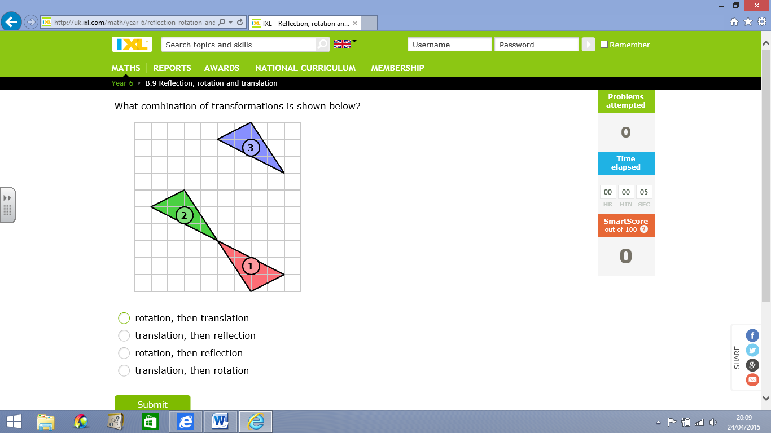  Describe exactly how the shape transforms from 1, to 2, to 3.  ____________________  ____________________  ____________________ | 14.  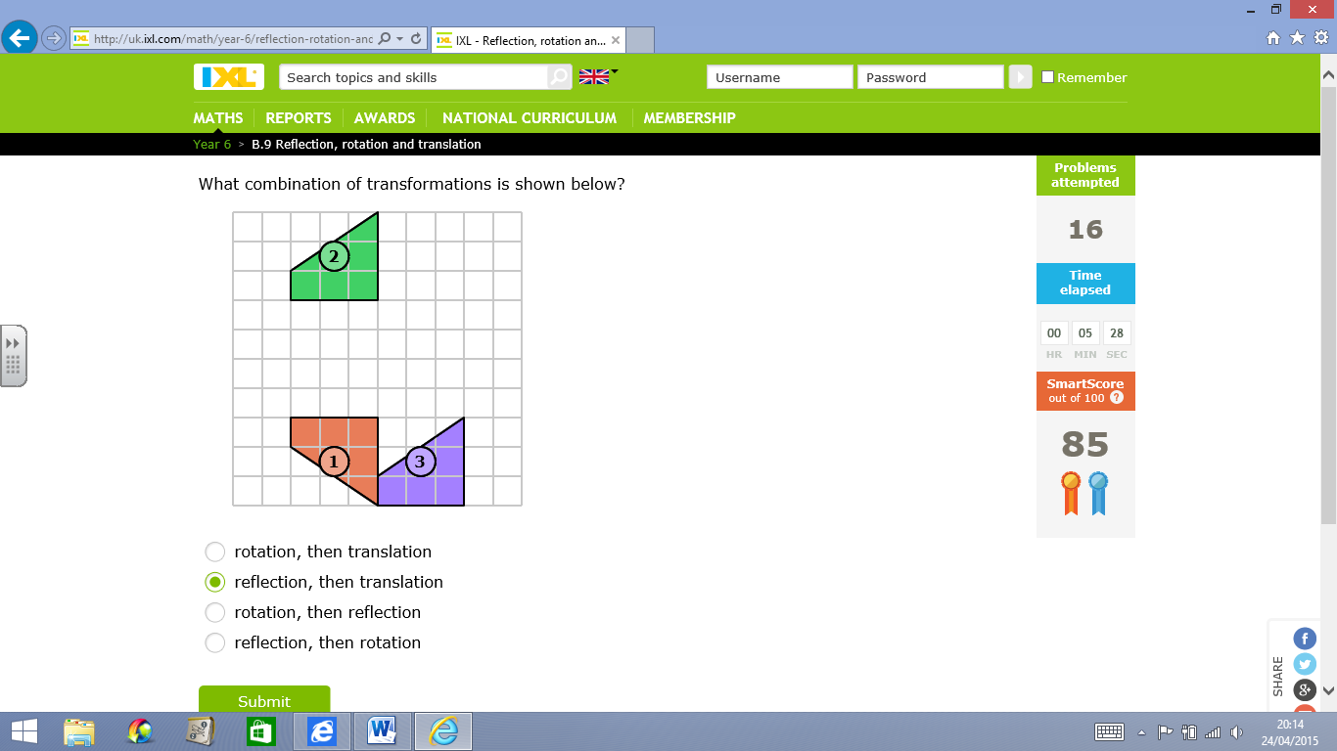  Describe exactly how the shape transforms from 1, to 2, to 3.  ____________________  ____________________  ____________________
FINALLY:
Describe: What is translating? What does it mean? ____________________________________________________
___________________________________________________________________________________________
Give 2 top tips to help someone else translate shapes: ___________________________________________________
___________________________________________________________________________________________


