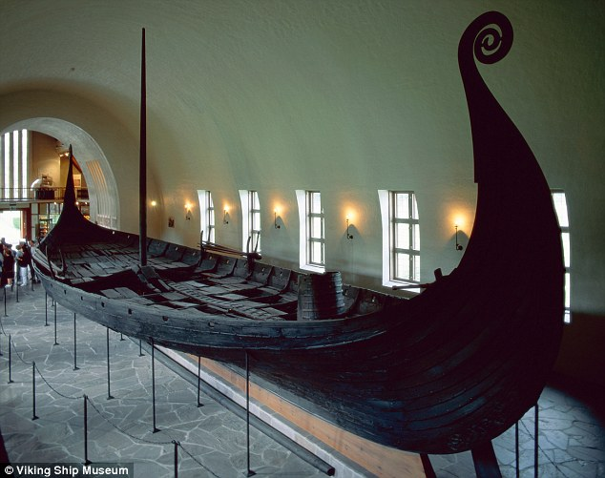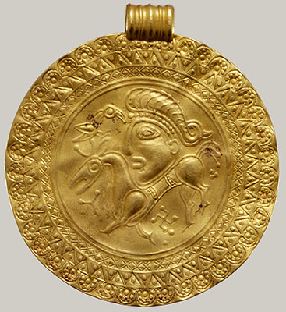

Music

Classical  
tradition – Concerto and Rondo.

Computing  
programming games using Kodu.

RE

Observing and discussing views on challenging questions such as ‘Who is God?’  
  
We will be applying these ideas through creative art forms, drama, art and music.

PE  
Gymnastics  
Tag Rugby

English

Our topic this term is Invasion! We will be looking at the settlers and invaders of Britain throughout history focussing on the Vikings and Anglo-Saxons.  
  
We have been reading and performing Viking saga stories. We will be writing our own hero sagas. This will help us to understand the culture of the Vikings. We will then answer the question ‘Do the Vikings deserve their reputation?’ in our non-fiction writing.

Our key texts are the Dragon’s Hoard and Beowulf.

Art

Viking themed dragon artwork.

Science

We are learning about electricity. We will then move on to pulleys and levers.

Maths

We will be looking at statistics, measures, algebra, ratio, proportion and shape as well as revisiting calculations, fractions, decimals and percentages throughout the term.

**Silver Birch – Spring Overview**

**Invasion!**