Special Events

Ugly bug ball

Art

Minibeast inspired mono prints

Clay bug characters

Butterfly painting symmetry

Making bug masks for the ugly bug ball

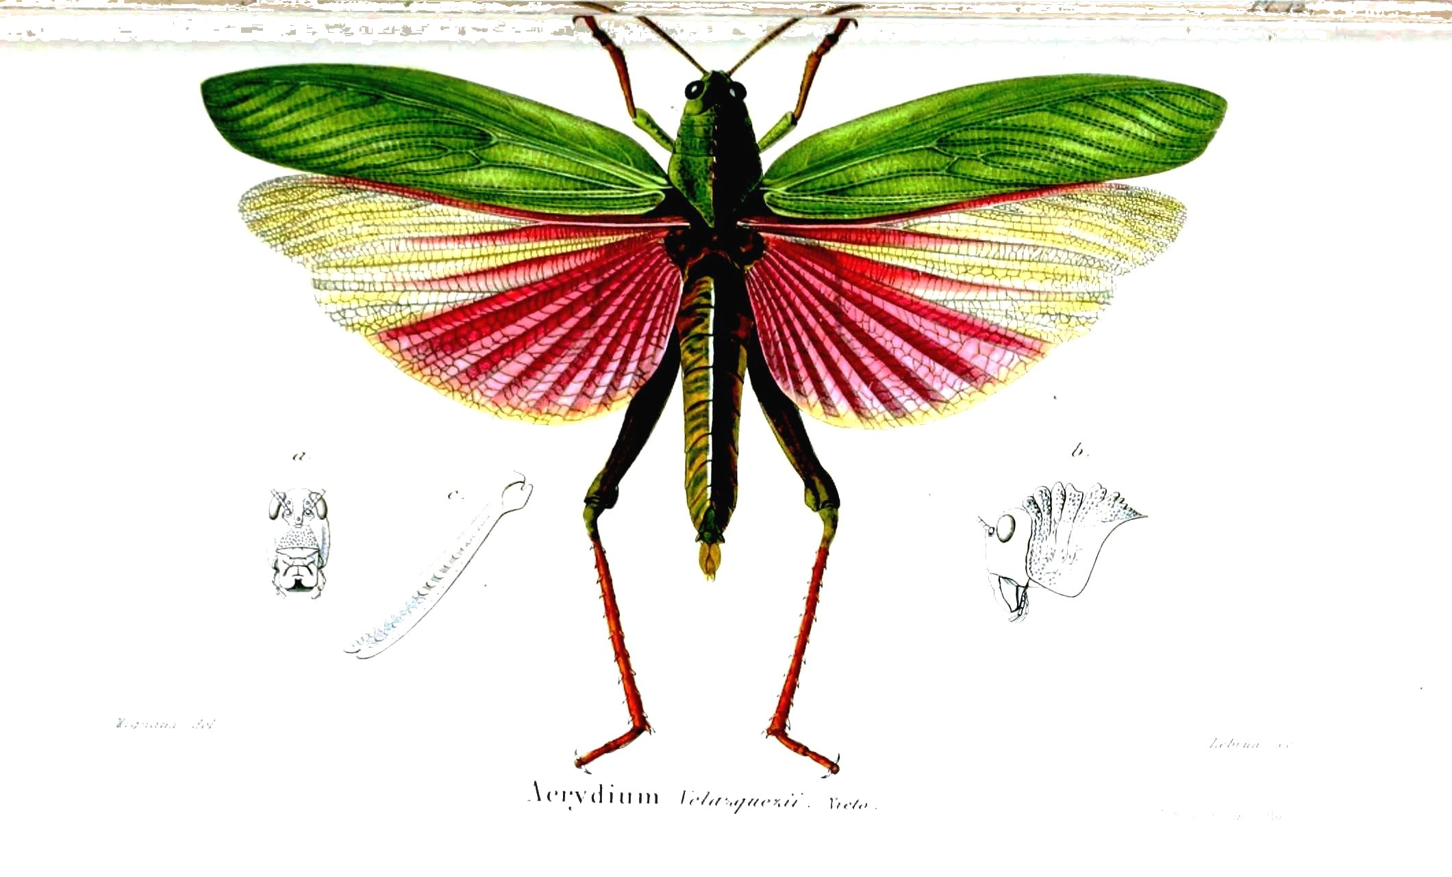

PSHCE

Moving on/feelings and self esteem

**Marvellous**

**Minibeasts**

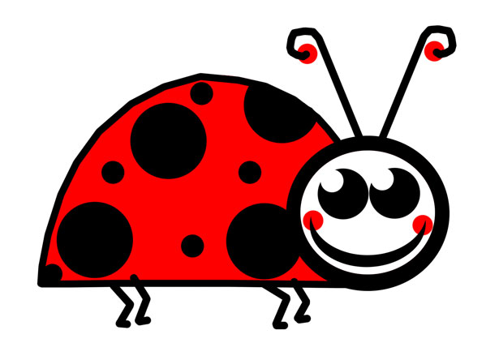

English

Key texts

Superworm, Julia Donaldson

The Snail and the Whale, Julia Donaldson

Mad about Minibeasts!, Giles Andreae

Spyder, Matt Carr

Insect Detective, Steve Voake

Snail Trail, Ruth Brown

Science

Investigation and classification - Minibeast hunt

Life cycle of a butterfly

Worm charming and making a class wormery

Bug habitats - make mini bug hotels and observe who moves in

Maths

Measurement- capacity, length, weight

Position and direction

Revision of calculation and number

Statistics

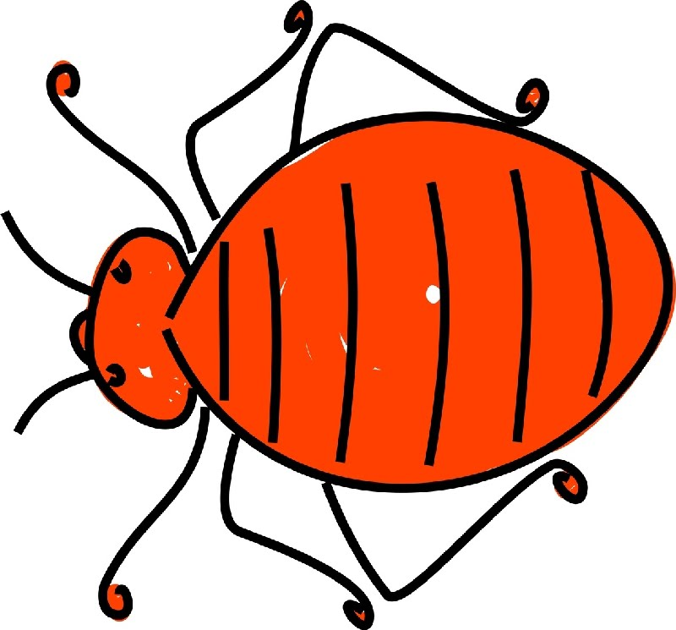

R.E

Why do Jewish families celebrate

Shabbat?

Music

Geography

Comparing Minibeasts in the UK to other parts of the world

Looking at our immediate environment for minibeasts

Create a local Minibeast map

**Clare James/Sarah Cheney**

**Year R/1/2**

P.E

Games

Athletics

Computing

Powerpoint - Presentation and research skills by making a Minibeast Fact File

Coding using Minecraft