English

Our topic this term is Ancient China. We will focus on the Shang dynasty, culture & food, farming, war and stories/legends.

Our key text is ‘The firework-maker’s daughter’ by Phillip Pullman. We have started writing adverts based around it. We will also be focussing on Ancient China and Rivers in non-fiction writing. We will be using the themes from ‘The firework-maker’s daughter’ to write our own stories later on in the term.

**Silver Birch – Autumn Overview**

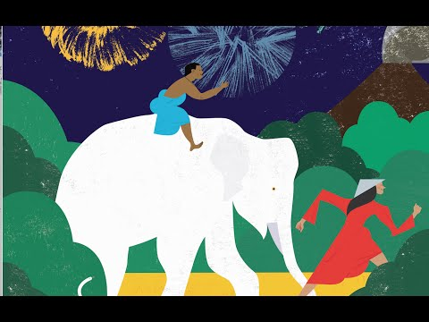

Science

We are focussing on the circulatory system, how the heart functions and how nutrients are transported around the body. This will also lead to some non-fiction writing in English.

Maths

We will focus on place value, addition and subtraction in the first part of term. We will then move on to multiplication and division before leading into fractions, decimals and percentages.

PE  
Outdoor and adventure games with an emphasis on communication and teamwork.

Art

Making ‘terracotta army’ figures from clay.

RE

Harvest

Buddhism

Computing

Making apps

Music

Harvest