Art/DT

New Zealand Hei Tiki Pendants

African Kalahari Desert Meerkat Collage

Trips/Special events

Showing Sunny (Our surprise guest) around our village

Drusillas Park (18.1.17)

P.E

Gymnastics

PSHCE

Working as a team

Getting along

Challenges

**Here, There and everywhere!**

English

Our focus is Non Fiction and we will be writing a leaflet about Bolney, researching continents and countries, picking out elements such as animals, culture and stories.

Key Texts:

Meerkat Mail

My Granny Went to Market, a round the World counting text

Meet the Meerkat

Let’s Celebrate, Festival poems from around the World

First News

The Week

National Geographic Meerkats

Usbourne Children’s Atlas

If the World were a Village

Running Wild

The Butterfly Lion

Maths

We will be focusing on the following areas:

Time, place value and money.

We will also be incorporating problem solving as a way of strengthening these mathematical skills. Reasoning and deepening concepts remain a constant focus.

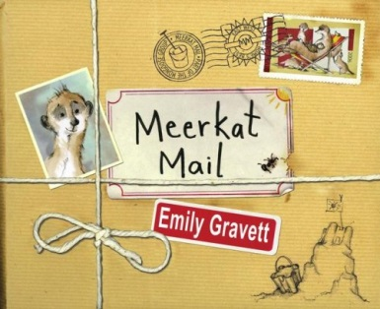

Geography/History

Looking at maps/aerial views

Planning a journey

Identifying continents and countries

Researching the cultures of other countries

Design our own flag (Paint)

Currencies of the world

Clare James

January/February 2017

Year 1/2

R.E

An exploration of different cultures and faiths in 4 countries around the World:

Haiti

Africa

India

Russia

Music

Music from around the world looking at pitch and timbre

Computing

Using Microsoft Word

Using Swiggle and Google to research countries and continents

Explain Everything app and Aurasma app

Logical Reasoning

Science

Weather - climate around the World

Seasons and changes